Minutes – CuS project meeting, February 22nd and 23rd, 2011

Date: Tuesday and Wednesday, February 22nd and 23rd, 2011
Time: 09:00 – 18:00 and 9:00 – 16:00
Place: Stockholm, Sweden
Participants: Christian Odgaard, Energinet.dk, DK
Emma Lindgren, Vattenfall, SE
Eva Lepperhoff (Convenor), RWE, DE
Gerrit Fokkema (Vice convenor), EDSN, NL
Jan Owe, SvK, SE
Joachim (Joe) Schlegel, RWE
Kees Sparreboom, TenneT, NL
Leif Morland, Logica, NO
Margit Reiter, Energie Ag, AT
Ove Nesvik (Secretary), EdiSys, NO

Enclosure:
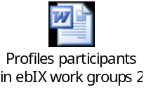, see 11.1, Profiles for participants in ebIX work groups, under AOB
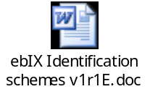, See 11.3, ebIX® identification schemes document

Approval of agenda
The agenda was approved with the following additions:
- Profiles for participants in ebIX work groups, see 11.1 under AOB
- Review of new proposal for Harmonised Role Model , see 11.2 under AOB

Minutes from previous meeting
The minutes from the previous CuS meeting were approved.

Resolve matters arising from the latest ebIX® Forum meeting (November 3rd 2010)
The processes for ordering of chargeable services that was discussed at the latest CuS meeting (October 2010) was briefly discussed at the ebIX® Forum meeting. The conclusion from the Forum was to move the task to the Vendor Group, who was asked to come up with project plans for the new projects:

- BRS Order Installation
  - BRS Order Meter (Re-)Placement
- BRS Billing:
  - BRS Billing Information for Grid Cost to Supplier
  - BRS Billing Information for Installation Rent to Supplier

The item was also added to the list of “Priorities for further work”, see item 9.

Further contact and cooperation with Eurelectric was put as an action item for Marc de Zwaan.

Presentation of ETC work on UMM 2 Business Choreography View and Business Information View
A first version of the UMM 2 Business Choreography View and Business Information View for the basic Change of Supplier process was published at the ebIX® web site, together with related XML schemas, after the previous CuS meeting. However these are no longer up to date, among others due to changes in the Transformation Tool (TT).

Kees mentioned that he just has uploaded two new ebIX® models, 2010A and 2010B, and that these include updated CuS documents. The CuS XML schemas published before Christmas will be removed from the ebIX® web site.

During the discussions it was asked if anybody new how much the ebIX® website is used.

Homework:
- Ove will remove old (not valid) CuS XML schemas from the ebIX® web site.
- Ove will ask Marc if it is possible to get some statistics of the usage of the ebIX® web site.

CuS model version 3.0
The first version 3.0 business requirements view documents was reviewed, with the following comments:

General
The class diagrams were changed, i.e. a Basic class, an Async addition class and an Additions class (in general) for all processes, e.g.:

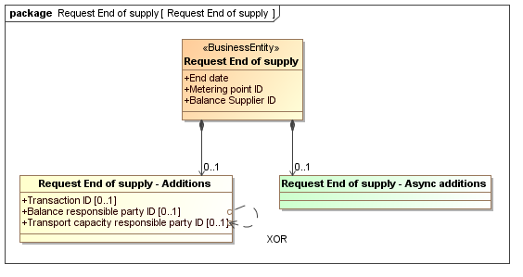

All attributes in the Additions class should be optional [0..1].

It was noted that many attributes are missing definitions. Ove will as homework for next meeting make a list over attributes, current definition and proposals for definitions where missing, but only for the processes reviewed.

Change of Supplier
Gerrit had noticed that the Change of supplier process is not completely correct in the Business Information Model. The confirmation of change of supplier is sent to the new balance supplier and the notification is sent to the old balance supplier and the old balance responsible party, but the new balance responsible party is nowhere informed. For the participating countries it is only Netherlands that informs the BRPs in the Change of Supplier process.

In case it is only the Netherlands that need to inform the BRPs on a metering point level the BRPs should be removed from the model, otherwise the information to the new BRP should be added.

Ove will send a mail to the CuS members/observers not participating at the meeting, i.e. Switzerland, Belgium, UK, Slovenia (David) and Estonia, asking if the BRPs are informed in CuS process on a MP level. What to do with the model, including consequences for other processes, such as End of supply will be discussed at the next meeting.

End of supply
The comments to the Business requirements view for End of supply from Christian, i.e. that the document is more detailed than he would prefer, was reviewed and the document was updated.

Ove will ask the not participating members if the BRPs are informed of End of supply (see above), or more correct of his end of balance responsibility.

It was a longer discussion related to if the Balance responsible party should be stated in the Request end of supply. The conclusion form the discussion was that we remove the Balance responsible party from the Request end of supply document and make it a general rule that we always model a minimum of business information entities (attributes) in the class diagrams in the Business requirements view. This means that we allow for interpretation, e.g. the process of End of supply means that both the BS and the BRP are ended, but without explicitly stating the BRP ID in the End of supply document.

Rules:
- We minimise the number of business information entities (attributes) in the class diagrams in the Business requirements view
- When changing a party connected to a MP we always send the MP ID, the Party ID and the Date.
- When changing the BS in MP (CuS, Move…), we always specify both the BS and BRP

The publication of the document will await the discussion on the next meeting related to information to the BRPs.

Request metering point characteristics
The Request metering point characteristics process was partly reviewed. A review of Response MP Characteristics will be put on top of the next agenda.

Consumer move
Gerrit and Emma commented that in the UseCase for Consumer move in, the Request consumer move in is included and the Change supplier is extended. Gerrit stressed that the Change supplier UseCase should be included in the Request consumer move in UseCase instead.

Ove will as homework update model artefacts according to comments from Gerrit and Emma.

The rest of the BRVs and other items were postponed until next meeting.

Homework:
- Ove will send a mail to the CuS members Switzerland, Belgium, UK, Slovenia (David) and Estonia asking if the BRPs are informed in Change of supplier and End of supply processes on a MP level.
- Ove will go through the UseCase descriptions and change to the newest version, such as changing the upper level UseCase description for End of supply.
- Ove will make a status presentation for the ebIX® Forum, that among others will include a presentation of the new class diagrams.
- Ove will make a list over attributes, current definition and proposals for definitions where missing.
- Ove will update Consumer move model artefacts according to comments from Gerrit and Emma.

Review of national code lists
Postponed

Updates of the ebIX® web-site
Postponed

Election of a CuS vice convenor
Eva informed that she is very busy implementing new main software in RWE until April 2012.

Gerrit was elected as vice convenor of CuS – CONGRATULATIONS!

Priorities for further work
Review of Due date for prioritised activities

# | Activity | Due date
 | Finalisation of 10 Business Requirements View documents  - Change of supplier, including all sub-processes  - End of supply  - Change of balance responsible party  - Change of transport responsible party  - Change of metered data responsible, including  - End of metered data responsible  - Customer move, both move in and move out  - Request metering point characteristics  - Notify metering point characteristics  - Query metering point data for identification | Spring 2011
 | Cancellation processes for all processes that can be cancelled | Autumn 2011
 | Update the model to include gas. | Autumn 2011
 | Distribute master data Meter  Including discussion of Control area and/or Imbalance settlement responsible | Autumn 2011
 | Efficient data alignment, including the possibility to request historical master data. | 2012
 | Request change of attributes connected to a MP | 2012
 | Request change of master data, meter | 2012
 | Change to/from Supplier of last resort  - Exist in Norway, Germany and Belgium.  - Does not exist in Austria, Sweden, Netherlands and Denmark.  - A Balance supplier appointed by the authorities (e.g. the regulator) to supply energy under certain conditions to consumers rejected by other Balance suppliers.  - And its relation to Change to/from Default supplier, i.e.:  - Does not exist in Austria, Norway, Netherlands and Belgium.  - Exist in Sweden, Germany and Denmark.  - A Balance supplier that supplies MPs within a Metering Grid Area (chosen by the MPA) when the customer has not chosen another BS | 2012
 | Change request and exchange of master data to other databases, such as parties and contracts. | To be decided
 | Class diagram for Installation information (inclusive "premise id" and "location id") and Exchange of master data for "Measuring field". This may require a recast of UTILMD. | To be decided
 | The ebIX Business domain model (chapter 2) will be moved to a separate document, common for all ebIX projects, in the next version of the model. | To be decided
 | How to handle the different attributes related to the Consumer, such as consumer contact information (e.g. address and invoice address). | To be decided
 | Ordering of chargeable services | To be decided

Meeting schedule
- May Wednesday 11th and Thursday 12th, Germany, Essen
  - Usage or BRP in Change of supplier and End of supply
  - Review Class diagram for Response MP characteristics
  - Customer move process
  - Distribute Documents for CuS, EoS, Request MP characteristics and Move
- June Tuesday 21th and Wednesday 22th, Norway (Haugesund)
- September Tuesday 6th and Wednesday 7th, Austria
- November Tuesday 15th and Wednesday 16th, Belgium, Switzerland or Netherlands

AOB

Profiles for participants in ebIX work groups
Kees has been asked from David Batic (Slovenia) to provide him with some profiles for Slovenian potential participants for ebIX wg’s. It was on too short notice to have the profiles discussed before within ebIX. But for our own benefit and in order to have something available for next situations, Kees would like to have a discussion of the attached document during the next CuS group meeting. So we will be able to present this kind of document before the next Forum.

- Background in retail part of the energy sector (preferably both gas and electricity)
- Working experience preferably in supplier company/department
- Representative for the national sector
- Some understanding of UML modeling (for business requirements)
- Fluent in English
- Open minded with regard to different circumstances in different countries

Review of new proposal for Harmonised Role Model
The new proposal for Harmonised Role Model was reviewed. There was a longer discussion related to the rename of the Local Metering Point to Accounting point. The Accounting point is still a generalisation of the Metering point and it will still be possible to use the term Metering point when we mean Accounting point (earlier Local metering point).

Kees will bring the following questions to EMD and thereafter to the ebIX® HG members:

- Why change name from Local Metering Point to Accounting point?
  - What are the consequences of the name change?
- Can a Metering point be an aggregation of Accounting points?
- Where is the Exchange metering point?
- If the Metering point is an Exchange metering point, what about the association with Functional group?

ebIX® identification schemes document
Kees asked, on behalf of Slovenia, what identification schemes are used for parties and domains in the different countries. This is however already listed in the ebIX® Identification scheme document, but for some reason it is not published on the ebIX® website. We will distribute the document and ask everyone to review and update appendix D, including gas.

Homework:
- Everyone is asked to review ebIX® Identification scheme document and update appendix D, including gas.
- Thereafter Ove will publish at the ebIX® website

- Member list

Members:
Name |  | Company | Telephone | Mobile | E-mail
Franz Fischer | AT | Energie Ag |  |  | margit.reiter@energieag.at
Margit Reiter | AT | Energie Ag | +4373290003508 | +43 664601653508 | franz.fischer@energieag.at
Patrick Dellaert | BE | UMIX |  |  | patrick.dellaert@eandis.be
Koen Reynvoet | BE | Indexis /UMIX |  | +32 478 340 695 | Koen.Reynvoet@umix.info
Sacha Perret | CH | swissgrid |  |  | Sacha.Perret@swissgrid.ch
Eva Lepperhoff (Convenor) | DE | RWE | +49 20112 49835 | +49 162 250 4430 | eva.lepperhoff@rwe.com
Joachim (Joe) Schlegel | DE | RWE | +49 2314384426 | +49 1722364396 | Joachim.Schlegel@rwe.com
Christian Odgaard | DK | Energinet.dk | +45 76 22 44 63 | +45 23 33 85 55 | cco@energinet.dk
Gerrit Fokkema  (Vice convenor) | NL | EDSN | +31 355 480 180 | +31 622907787 | gerrit.fokkema@edsn.nl
Kees Sparreboom | NL | TenneT |  | +31 622 66 7911 | kees.sparreboom@capgemini.com
Leif Morland | NO |  | +47 52 86 70 12 | +47 934 08 717 | leif.morland@logica.com
Ove Nesvik (Secretary) | NO | EdiSys | +47 22 42 13 80 | +47 928 22 908 | ove.nesvik@edisys.no
Tor Heiberg | NO | Statnett | +47 22 52 70 00 | +47 99353 969 | tor.heiberg@statnett.no
Emma Lindgren | SE | Vattenfall | +46 8 687 3112 | ++46 70 311 0957 | emma.lindgren@vattenfall.com
Boštjan Topolovec | SI | Represent Section IPET |  |  | bostjan.topolovec@sodo.si

Observers:
Thilo.Lombardo | DE | EDNA | +49 241/9671 194 | +49 172/7181742 | Thilo.Lombardo@kisters.de
Anita Buchholz/  Jörg Ferchow | DE | SAP | +49 6227 748487 | +49 171/3085281 | anita.buchholz@sap.com  joerg.ferchow@sap.com
Stefan Weyand | DE | cx4u |  |  | Stefan.Weyand@cx4u.com
Erkki Lindepuu | EE | Estonian Energy |  |  | Erkki.Lindepuu@energia.ee
Priit Tampere | EE | Estonian Energy |  |  | Priit.Tampere@energia.ee
Anne Gaëlle Le Saout | FR | EDF Réseau de Distribution |  |  | anne-gaelle.le-saout@distribution.edf.fr
Danièle Bui | FR | EDF Réseau de Distribution |  |  | daniele.bui@distribution.edf.fr
Sylvie Malet | FR | EDF R&D |  |  | Sylvie.Mallet@edf.fr
Juraj Horvat | SK | Vychodoslovenska energetika a. s | +421 55 610 2951 | +421 915 932 285 | horvat_juraj@vse.sk
Gordon Brown | UK | AMT-Sybex | +44 2 890 781 616 | +44 7 808 901 219 | Gordon.Brown@AMT-Sybex.com

- National code lists

National codes overview March 2010

  - Belgium
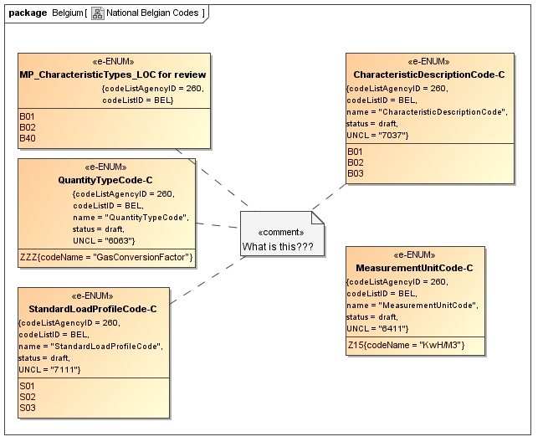

  - Norway
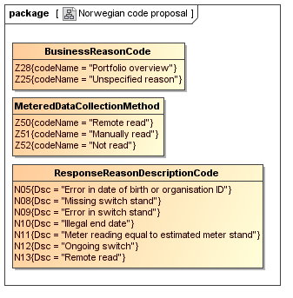

  - Sweden



  - Switzerland
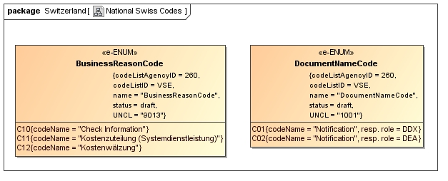

From Jan:
Z22 Change of supplier (Z0xL) should be the same as E03 Change of balance supplier
Z23 Change of customer and supplier (Z0xLK) should be the same as E35 Combined customer and supplier switch
Z24 Cancellation of change procedure (Z0xC) should be the same as E05 Cancellation
Z25 Unspecified reason (Z08H) is not defined in ebIX
Z26 Change to default supplier (Z04A) is not defined in ebIX
Z27 Change of balance responsible (Z09B) should be the same as E56 Change of Balance Responsible Party

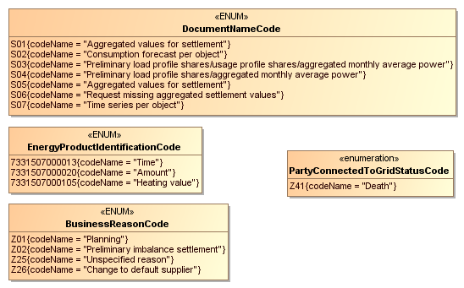

  - The Netherlands


