Content
1 Introduction 3
1.1 Terms and notation 3
2 Accounting Point characteristics class diagram 4
2.1 Element definitions from ebIX®: Accounting Point characteristics 5
3 Mapping of Accounting Point characteristics class from ebIX® to basic CIM/ESMP 11
3.1 Class diagram: Mapping to basic CIM 11
3.2 Class diagram: Mapping to basic ESMP 12
3.3 Mapping table incl. MR proposals 13
4 Mapping of Accounting Point address class from ebIX® to CIM 14
4.1 Class diagram: Mapping to basic CIM 14
4.2 Class diagram: Mapping to basic ESMP 15
4.3 Mapping table incl. MR proposals 16
5 Mapping of Geographical coordinate class from ebIX® to CIM 17
5.1 Class diagram: Mapping to basic CIM 17
5.2 Class diagram: Mapping to basic ESMP 18
5.3 Mapping table incl. MR proposals 19
6 Mapping of Accounting Point party class from ebIX® to CIM 20
6.1 Class diagram: Mapping to basic CIM 20
6.2 Class diagram: Mapping to basic ESMP 21
6.3 Mapping table incl. MR proposals 22
7 Mapping of Customer class from ebIX® to CIM 23
7.1 Class diagram: Mapping to basic CIM 23
7.2 Class diagram: Mapping to basic ESMP 24
7.3 Mapping table incl. MR proposals 24
8 Mapping of Customer identification class from ebIX® to CIM 25
8.1 Class diagram: Mapping to basic CIM 25
8.2 Class diagram: Mapping to basic ESMP 26
8.3 Mapping table incl. MR proposals 26
9 Mapping of AP physical characteristics class from ebIX® to CIM 27
9.1 Class diagram: Mapping to basic CIM 27
9.2 Class diagram: Mapping to basic ESMP 28
9.3 Mapping table incl. MR proposals 28
10 Mapping of AP administrative characteristics class from ebIX® to CIM 31
10.1 Class diagram: Mapping to basic CIM 31
10.2 Class diagram: Mapping to basic ESMP 32
10.3 Mapping table incl. MR proposals 33
11 Mapping of Metering Grid Area class from ebIX® to CIM 35
11.1 Class diagram: Mapping to basic CIM 35
11.2 Class diagram: Mapping to basic ESMP 35
11.3 Mapping table incl. MR proposals 36
12 Mapping of Aggregated Reception Station class from ebIX® to CIM 37
12.1 Class diagram: Mapping to basic CIM 37
12.2 Class diagram: Mapping to basic ESMP 37
12.3 Mapping table incl. MR proposals 38
13 Mapping of Calorific Value Area class from ebIX® to CIM 39
13.1 Class diagram: Mapping to basic CIM 39
13.2 Class diagram: Mapping to basic ESMP 39
14 Mapping of Energy label class from ebIX® to CIM 41
14.1 Class diagram: Mapping to basic CIM 41
14.2 Class diagram: Mapping to basic ESMP 41
14.3 Mapping table incl. MR proposals 42
15 Mapping of AP billing characteristics from ebIX® to CIM 43
15.1 Class diagram: Mapping to basic CIM 43
15.2 Class diagram: Mapping to basic ESMP 44
15.3 Mapping table incl. MR proposals 44
16 Mapping of Energy volume information class from ebIX® to CIM 45
16.1 Class diagram: Mapping to basic CIM 45
16.2 Class diagram: Mapping to basic ESMP 46
16.3 Mapping table incl. MR proposals 46
17 Mapping of Estimated annual volume class from ebIX® to CIM 47
17.1 Class diagram: Mapping to basic CIM 47
17.2 Class diagram: Mapping to basic ESMP 48
17.3 Mapping table incl. MR proposals 48
18 Mapping of AP Measurement characteristics class from ebIX® to CIM 50
18.1 Class diagram: Mapping to basic CIM 50
18.2 Class diagram: Mapping to basic ESMP 51
18.3 Mapping table incl. MR proposals 52

Introduction
This document shows a proposal how to map the Accounting Point characteristics class diagram, found in the ebIX® BRS for Alignment of Accounting Point characteristics, to basic CIM (62325-301, 61968-11 and/or 61970-301) and to ESMP (62315-351).

Terms and notation
- «realize» dependencies are used to show mapping between classes, and between attributes and classes.
- «mapsTo» dependencies are used to show mapping between attributes.
- Classes from the ebIX® model are stereotyped «BusinessEntity».

Accounting Point characteristics class diagram
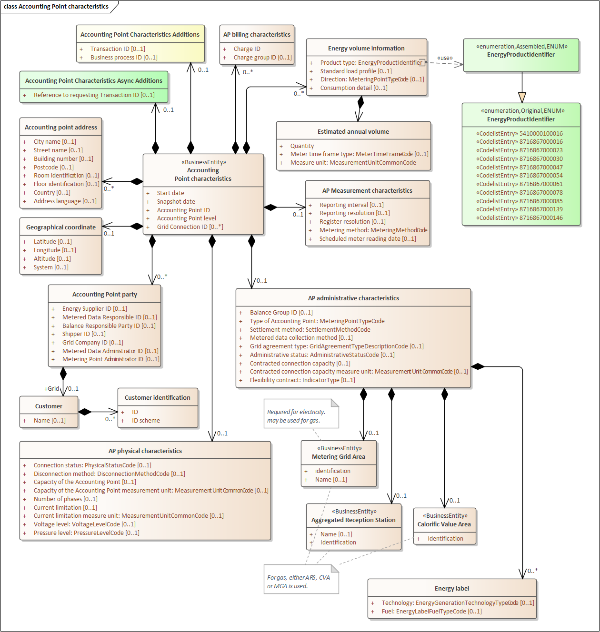
Figure 1 Accounting Point characteristics class diagram from ebIX® BRS for Accounting Point characteristics

Element definitions from ebIX®: Accounting Point characteristics
Class/attribute | Sector | Description
«Business entity»  Accounting Point characteristics |  | The information set to be sent to a Linked Party to the Accounting Point:  - Balance Responsible Party  - Energy Supplier  - Grid Company  - Metered Data Aggregator  - Metered Data Responsible  - Reconciliation Responsible  - Shipper  a Consented Party, the Meter Administrator or the Flexibility Register Administrator to the Accounting Point from the Metering Point Administrator when Notifying responding to a request for Accounting Point characteristics for a specified Accounting Point.
Start date |  | The date when the content of this business document becomes or became valid.
Snapshot date |  | The date and time when the set of information was extracted from the Metering Point administration.
Accounting Point ID |  | The unique identification of the Accounting Point.
Accounting Point level |  | The hierarchical position of this Accounting Point in relation to the linked Accounting Point, i.e. main Accounting Point or sub–Accounting Point.
Grid Connection ID |  | The unique identification of the connection from this Accounting Point to the grid.
Accounting Point address |  | The address of the Accounting Point.  May be repeated if more than one language is used nationally.
City name |  | The name, expressed as text, of the city, town or village of this address.
Street name |  | The name, expressed as text, of this street or thoroughfare of this address.
Building number |  | The number, expressed as text, of the building or house on this street at this address.
Postcode |  | The code specifying the postcode of this address.
Room identification |  | The identification, expressed as text, of the room, suite, office or apartment as part of this address.
Floor identification |  | The identification by name or number, expressed as text, of the floor in the building as part of this address.
Country |  | The unique identifier of the country for this address (Reference ISO 3166 and UN/ECE Rec 3).
Address language |  | The language in which the address is specified, using ISO 639-1 two-digit language code
Geographical coordinate |  | The set of geographical coordinates of this Accounting Point.
Latitude |  | The measure of the latitude as an angular distance north or south from the Equator meridian to the meridian of this Accounting Point for this geographical coordinate. (Reference ISO 6709).
Longitude |  | The measure of the longitude as an angular distance east or west from the Greenwich meridian to the meridian of this Accounting Point (Reference ISO 6709).
Altitude | Gas | The measure of the altitude that reflects the vertical elevation of this Accounting Point above a surface for this geographical coordinate (Reference ISO 6709).
System |  | The unique identifier of the reference system used for measuring this geographical coordinate.
Accounting Point party |  | The party that has a relevant responsibility for this Accounting Point.
Energy Supplier ID |  | The unique identification of the Energy Supplier responsible for energy supply for this Accounting Point.
Metered Data Responsible ID |  | The unique identification of the Metered Data Responsible, responsible for the metering of this Accounting Point.
Balance Responsible Party ID |  | The unique identification of the Balance Responsible Party responsible for balancing the energy for this Accounting Point.
Shipper ID |  | The unique identification of the Shipper responsible for capacity management of the energy for this Accounting Point.
Grid Company ID |  | The unique identification of the Grid Company responsible for technical maintenance and operation of the connection of this Accounting Point.
Metered Data Administrator ID |  | The unique identification of the Metered Data Administrator, responsible for the administration of the measured data for this Accounting Point.
Metering Point Administrator ID |  | The unique identification of the Metering Point Administrator, responsible for the administration of this Accounting Point.
Grid Customer |  | The Customer that has the contract for access and transport of energy for this Accounting Point.
Name |  | The name of the Grid Customer
Customer identification |  | The Identification of a Customer
ID |  | The unique identification of the Customer at the Accounting Point.
ID scheme |  | The Identification scheme used for the identification of the Customer in question
AP physical characteristics |  | The relevant physical characteristics of this Accounting Point.
Connection status |  | A code specifying if the installation of the Accounting Point is physically connected to the grid and energy flow is possible.
Disconnection method |  | The Disconnection Method is an indication of how the Accounting Point is physically connected or disconnected.
Capacity of the Accounting Point |  | Capacity of an Accounting Point is the maximum physical capacity of the Accounting Point.  For electricity, the maximum capacity for the Accounting Point is given in kW or MW or calculated from the nominal voltage level, number of phases and current limitations. The “Capacity of an Accounting Point” can be sent as the calculated capacity in kW or MW and/or as a combination of:  - Number of phases  - Fuse size  - Voltage level
Capacity of the Accounting Point measure unit |  | The measure unit used for the capacity of the Accounting Point.  For gas the maximum capacity for the Accounting Point is given in m³/hour, usually determined by the physical constraints of the (nozzles in the) Meter.
Number of phases | Elec | The number of phases in the Accounting Point, either 1 or 3.
Current limitation | Elec | The current limitation, i.e. maximum current or fuse size, for the Accounting Point in Ampere
Current limitation measure unit | Elec | The measure unit used for the current limitation, i.e. Ampere
Voltage level | Elec | A code specifying the voltage level of the grid to which the installation of the Accounting Point is connected.
Pressure level | Gas | A code specifying the gas pressure in the grid to which the installation of the Accounting Point is connected.
AP Administrative characteristics |  | The relevant administrative characteristics of this Accounting Point.
Balance Group ID |  | The unique identification of the Balance Group to which this Accounting Point belongs.
Type of Accounting Point |  | A code specifying the direction of the active energy flow in this Accounting Point, such as consumption, production or combined.
Settlement method |  | A code specifying how the energy volumes are treated for settlement for this Accounting Point, such as profiled or non-profiled.
Metered data collection method |  | A code specifying how a Metered Data Collector collects data from the Meter for this Accounting Point, such as Automatic or Manually.
Grid agreement type |  | Specification of type of grid contract, such as if the contract is directly between the Grid Company and the Grid Customer, or through the Energy Supplier.
Administrative status |  | A code specifying whether (or not) the Accounting Point is part of the imbalance settlement.
Contracted connection capacity |  | Quantitative information about the capacity of the connection that is contracted for the Accounting Point.
Contracted connection capacity measure unit |  | The unit of measure used for the Contracted Connection Capacity.
Flexibility contract |  | Indicates if there is a contract at the Accounting Point for flexibility services from this Accounting Point. The element is Boolean and used for both gas and electricity.
Energy label |  | A class indicating the origin of the energy produced at this Accounting Point
Technology |  | An indication of the technology of the energy production, or part of the energy production, which is potentially fed into the grid at this Accounting Point.
Fuel |  | An indication of the fuel used for the energy production, or part of the energy production, which is potentially fed into the grid at this Accounting Point.
«Business entity»  Metering Grid Area | Elec | The Metering Grid Area the Accounting Point belongs to. The Metering Grid Area is a physical area where consumption, production and exchange of (electrical) energy can be metered.
Identification |  | The unique identification of the Metering Grid Area to which this Accounting Point belongs.
MGA name |  | The name, in clear text, of the Metering Grid Area.
«Business entity»  Aggregated Reception Station | Gas | An administrative entity that represents one or more Reception Stations for gas where the gas quality is regarded to be the same.  Dependency: Use either Aggregated Reception Station or Calorific Value Area.
Identification |  | The unique identification of the Aggregated Reception Station to which this Accounting Point belongs.
Name |  | The name, in clear text, of the Aggregated Reception Station.
«Business entity»  Calorific Value Area | Gas | A set of Accounting Points where the calorific value for the quality of supplied gas is assumed to be the same.
Identification |  | The unique identification of the Calorific Value Area to which this Accounting Point belongs.
AP billing characteristics |  | The relevant billing characteristics of this Accounting Point.
Charge ID |  | The unique identification of the Charge applicable for this Accounting Point.
Charge group ID |  | The unique identification of the Charge group applicable for this Accounting Point. A Charge group is a set of Charges valid for a set of Accounting Point with similar characteristics.
Energy volume information |  | Characteristics of the energy volume for this Accounting Point, among others for reconciliation purposes.
Product type |  | A code specifying the energy product for the estimated annual volume.
Standard load profile |  | The standard load profile for this Accounting Point.
Direction |  | A code specifying the direction of the energy flow to an/or from this Accounting Point, such as consumption or production or both.
Consumption detail |  | An indication of the kind of consumption at this Accounting Point, such as production unit’s own consumption, pumped or disconnectable consumption.
Estimated annual volume |  | The energy volume used for profiled nomination and allocation for this Accounting Point.
Quantity |  | The estimated annual volume for the specified time frame.
Meter time frame type | Elec | A code specifying the tariff time frame for this estimated annual volume.
Measure unit |  | The unit of measure used for the Estimated Annual Volume.
AP measurement characteristics |  | Characteristics of the measurement reporting from this Accounting Point.
Reporting interval |  | The time between publications of meter readings from the Metered Data Administrator, expressed in compliance with ISO 8601 in the following format:  PnYnMnDTnHnMnS.  For example PT1D for daily publications.
Reporting resolution |  | The length of each observation that is reported to the market from the Metered Data Administrator, expressed in compliance with ISO 8601 in the following format:  PnYnMnDTnHnMnS.  For example PT1H for hourly resolution.
Register resolution |  | The length of each observation that is registered in the Register in the Meter, expressed in compliance with ISO 8601 in the following format:  PnYnMnDTnHnMnS.  For example PT15M for 15 minutes resolution.
Metering method |  | A code specifying how the energy volumes are established for this Accounting Point, such as continuous- non-continuous- or not-metered.
Scheduled meter reading date |  | The indication of when the regular meter reading is scheduled.
Accounting Point characteristics Additions |  | Information related to the exchange of the Request Accounting Point characteristics, to be agreed on a national level.
Transaction ID |  | The unique identification of this set of information, given by the Initiator.
Business process ID |  | The unique identification, given by the Metering Point Administrator, of this Request Accounting Point characteristics process that this exchange is part of.
Accounting Point characteristics Async Additions |  | Information related to the exchange of the request for Accounting Point characteristics, needed when using asynchronous communication.
Reference to requesting Transaction ID |  | A reference to the requesting business document, used in the responding business document in a business transaction.  Only used when responding to a request.
Table 1 Element definitions from ebIX®: Accounting Point characteristics

Mapping of Accounting Point characteristics class from ebIX® to basic CIM/ESMP

Class diagram: Mapping to basic CIM
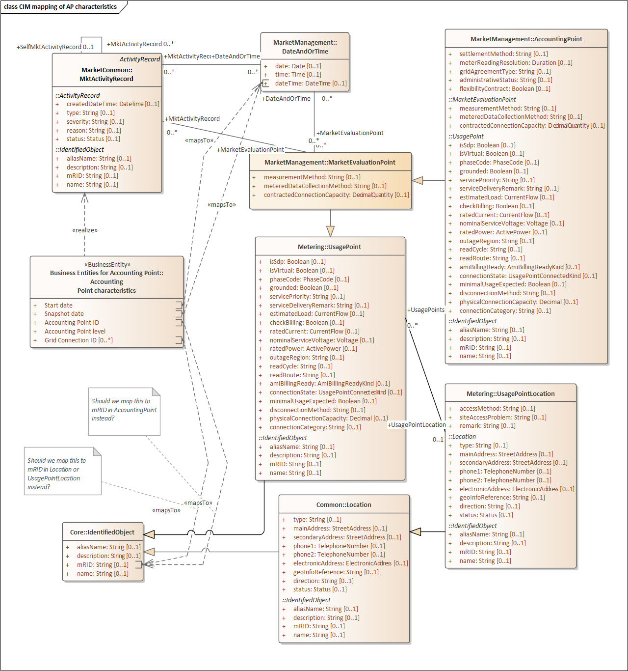
Figure 2 Mapping of Accounting Point characteristics class from ebIX® to basic CIM

Class diagram: Mapping to basic ESMP
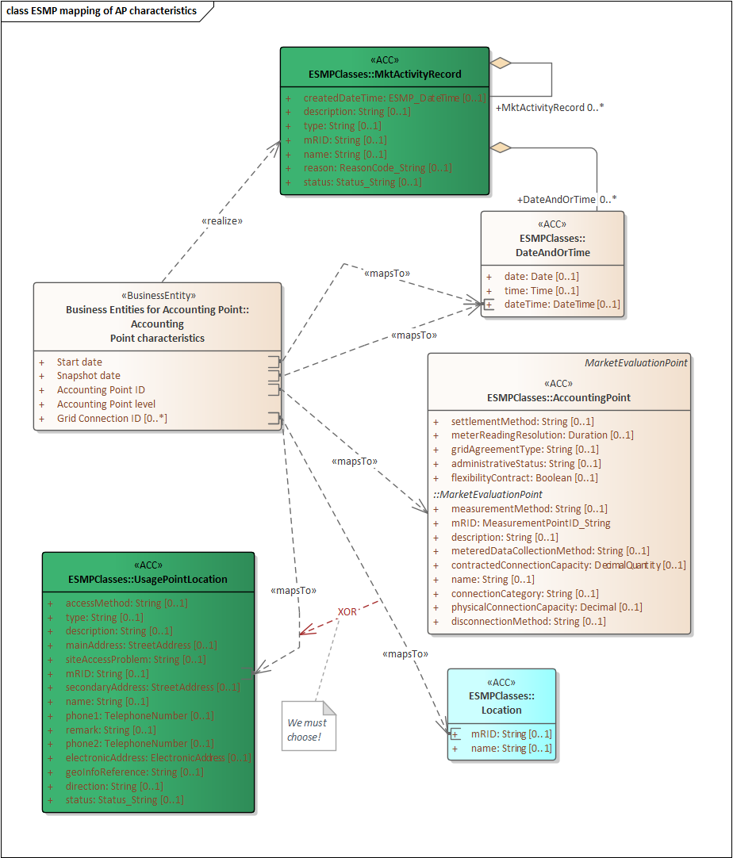
Figure 3 Mapping of Accounting Point characteristics class from ebIX® to ESMP

Mapping table incl. MR proposals
ebIX® attribute | CIM attribute | ESMP attribute | MR / Comment
Start date | IEC62325/ MarketManagement/ DateAndOrTime/ dateTime | IEC62325-351/ ESMPClases/ DateAndOrTime/ dateTime
Snapshot date | IEC62315/ MarketManagement/ DateAndOrTime/ dateTime | IEC62325-351/ ESMPClases/ DateAndOrTime/ dateTime
Accounting Point ID | IEC62315/ MarketManagement/ AccountingPoint/ mRID | IEC62325-351/ ESMPClases/ AccountingPoint/ mRID
Accounting Point level |  |  | Addition of an Accounting Point level attribute in the AccountingPoint class in both IEC 62325-301 and IEC 62325-351. Definition:  The hierarchical position of this Accounting Point in relation to the linked Accounting Point, i.e. main Accounting Point or sub–Accounting Point.
Grid Connection ID | IEC61968/ Metering/ UsagePointLocation/ mRID  Or  IEC61968/ Common/ Location/ mRID | IEC62325-351/ ESMPClases/ UsagePointLocation/ mRID  Or  IEC62325-351/ ESMPClases/ Location/ mRID | If Grid Connection ID will be mapped to Location:  - Addition of an association from MktActivityRecord to Location in IEC 62325-351.

Candidates for MRs:
- No MRs needed.

Mapping of Accounting Point address class from ebIX® to CIM

Class diagram: Mapping to basic CIM
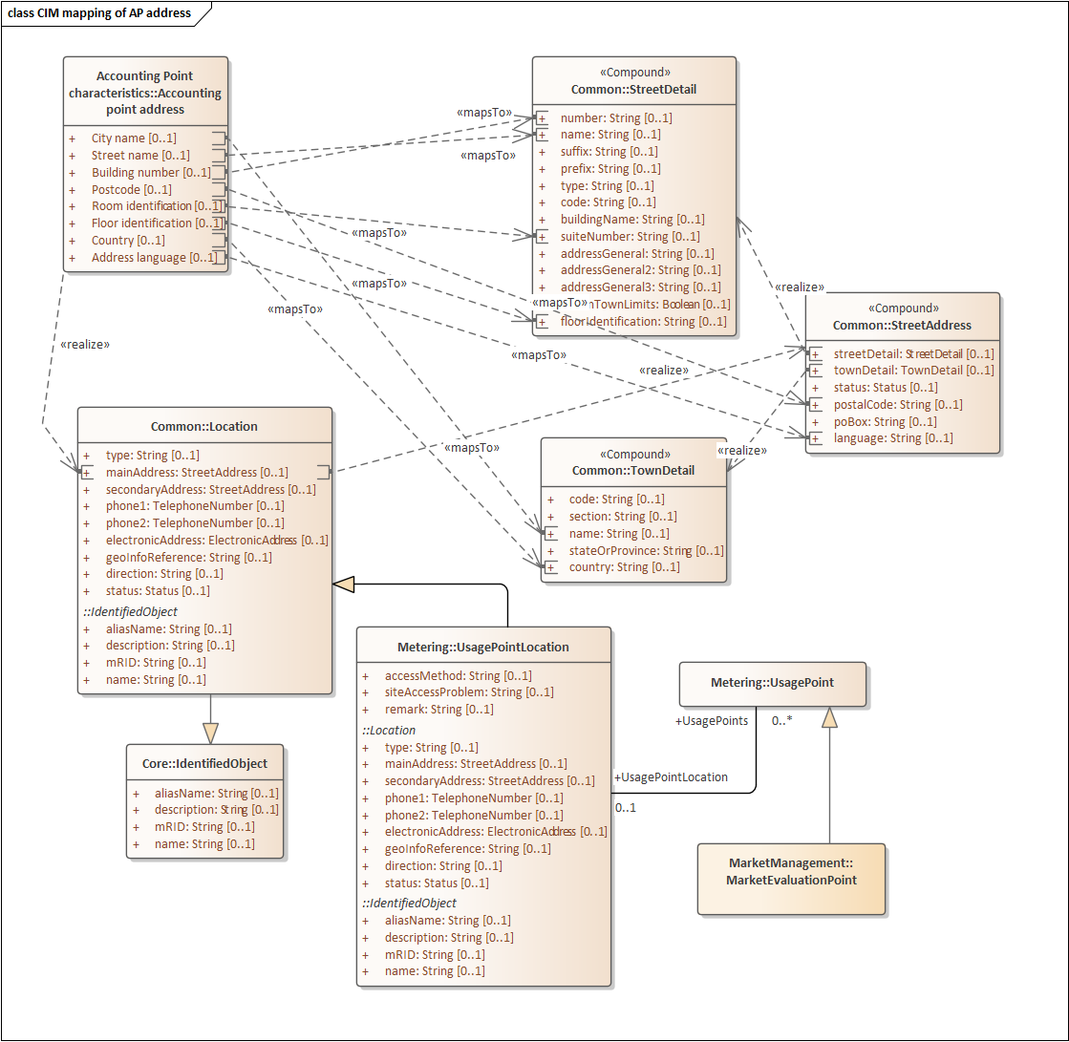
Figure 4 Mapping of Accounting Point address class from ebIX® to basic CIM

Class diagram: Mapping to basic ESMP
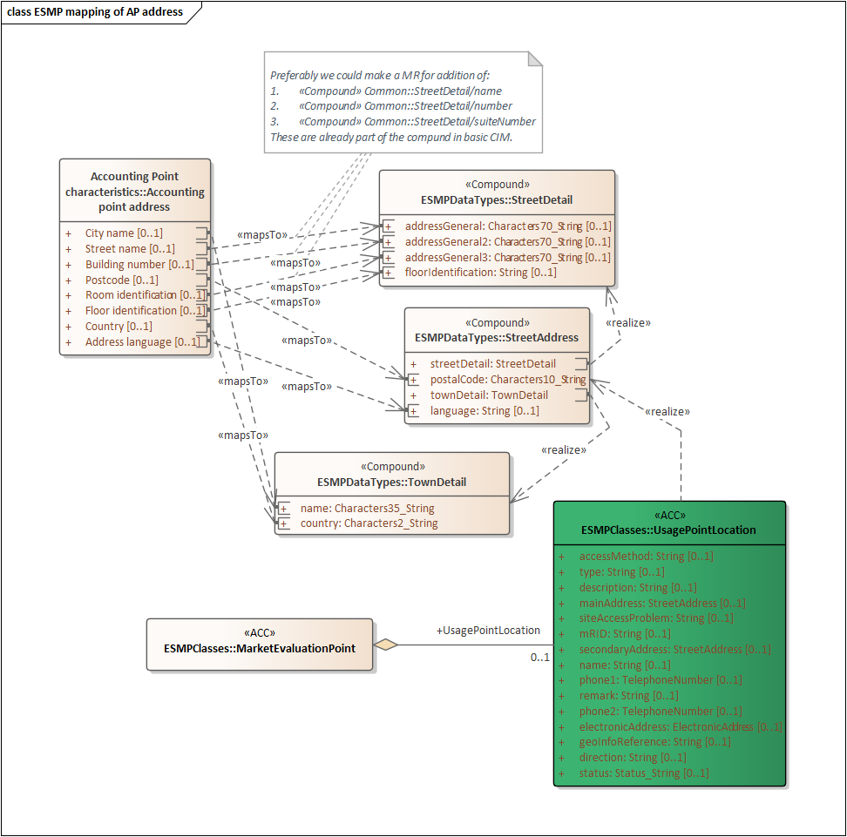
Figure 5 Mapping of Accounting Point address class from ebIX® to ESMP

Mapping table incl. MR proposals
ebIX® attribute | CIM attribute | ESMP attribute | MR / Comment
City name | IEC61968/ Common/ «Compound» TownDetail/ name | IEC62325-351/ ESMPDataTypes/ «Compound» TownDetail/ name
Street name | IEC61968/ Common/ «Compound» StreetDetail/ name | IEC62325-351/ ESMPDataTypes/ «Compound» StreetDetail/ name | This requires a MR for addition of «Compound» StreetDetail/name  Or  Mapping to «Compound» StreetDetail/ addressGeneral
Building number | IEC61968/ Common/ «Compound» StreetDetail/ number | IEC62325-351/ ESMPDataTypes/ «Compound» StreetDetail/ number | This requires a MR for addition of «Compound» StreetDetail/number  Or  Mapping to «Compound» StreetDetail/ addressGeneral2
Postcode | IEC61968/ Common/ «Compound» StreetAddress/ postalCode | IEC62325-351/ ESMPDataTypes/ «Compound» StreetAddress/ postalCode
Room identification | IEC61968/ Common/ «Compound» StreetDetail/ suiteNumber | IEC62325-351/ ESMPDataTypes/ «Compound» StreetDetail/ suiteNumber
Floor identification | IEC61968/ Common/ «Compound» StreetDetail/ floorIdentification | IEC62325-351/ ESMPDataTypes/ «Compound» StreetDetail/ floorIdentification | This requires a MR for addition of «Compound» StreetDetail/ floorIdentification  Or  Mapping to «Compound» StreetDetail/ addressGeneral3
Country | IEC61968/ Common/ «Compound» TownDetail/ country | IEC62325-351/ ESMPDataTypes/ «Compound» TownDetail/ country
Address language | IEC61968/ Common/ «Compound» StreetAddress / language | IEC62325-351/ ESMPDataTypes/ «Compound» StreetAddress / language
Note: See also issue 5318 in Redmine.
Candidates for MRs:
- No MRs needed.

Mapping of Geographical coordinate class from ebIX® to CIM

Class diagram: Mapping to basic CIM
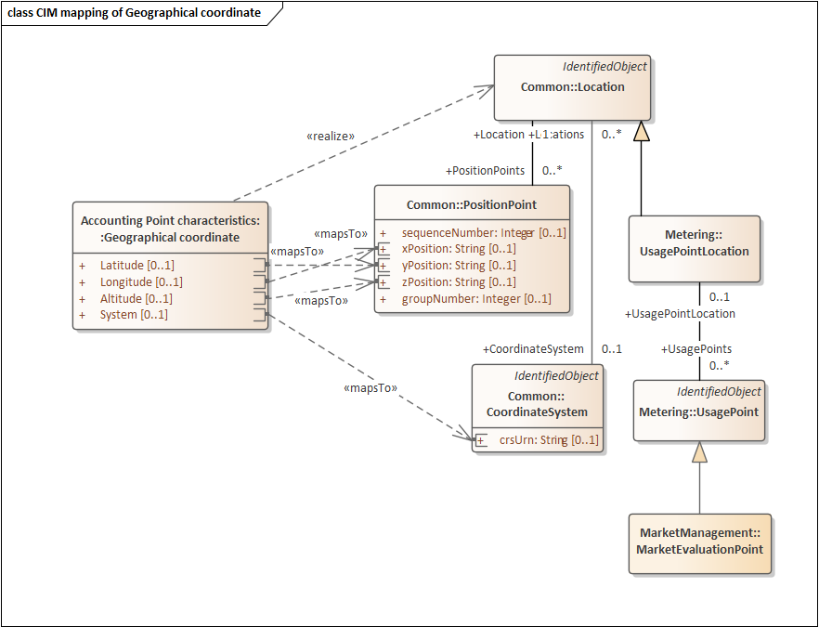
Figure 6 Mapping of Geographical coordinate class from ebIX® to basic CIM

Class diagram: Mapping to basic ESMP
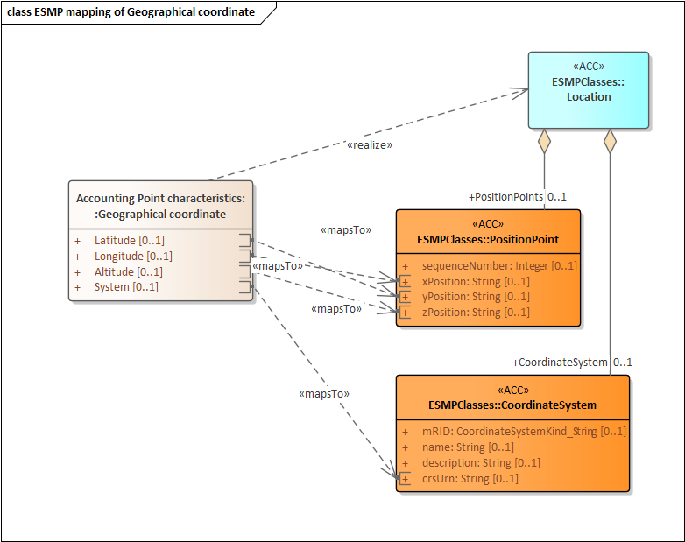
Figure 7 Mapping of Geographical coordinate class from ebIX® to ESMP

Mapping table incl. MR proposals
ebIX® attribute | CIM attribute | ESMP attribute | MR / Comment
Latitude | IEC61968/ Common/ PositionPoint/ yPosition | IEC62325-351/ ESMPClases/ PositionPoint/ yPosition
Longitude | IEC61968/ Common/ PositionPoint/ xPosition | IEC62325-351/ ESMPClases/ PositionPoint/ xPosition
Altitude | IEC61968/ Common/ PositionPoint/ zPosition | IEC62325-351/ ESMPClases/ PositionPoint/ zPosition
System | IEC61968/ Common/ CoordinateSystem/ crsUrn | IEC62325-351/ ESMPClases/ CoordinateSystem/ crsUrn

Candidates for MRs:
- Addition of an association from MarketEvaluationPoint to Location in IEC 62325-351.

Mapping of Accounting Point party class from ebIX® to CIM

Class diagram: Mapping to basic CIM
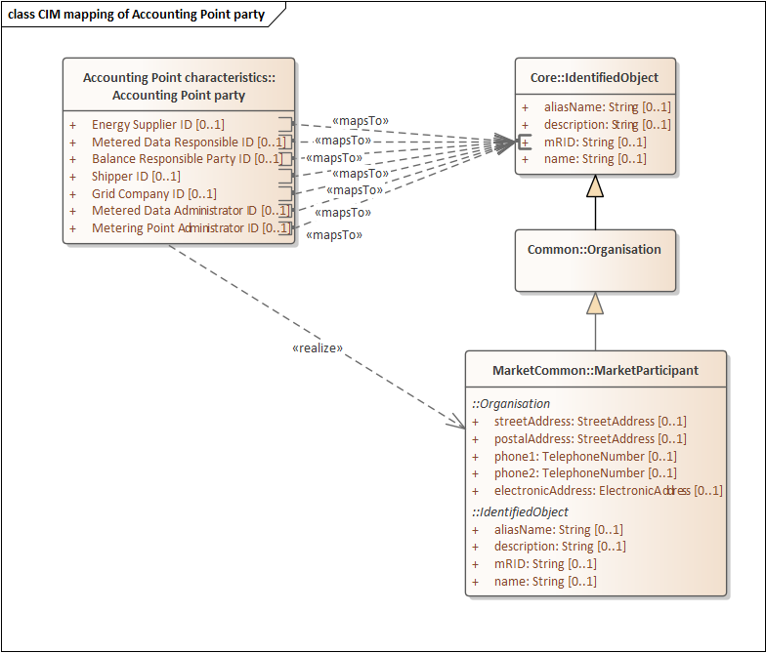
Figure 8 Mapping of Accounting Point party from ebIX® to basic CIM

Class diagram: Mapping to basic ESMP
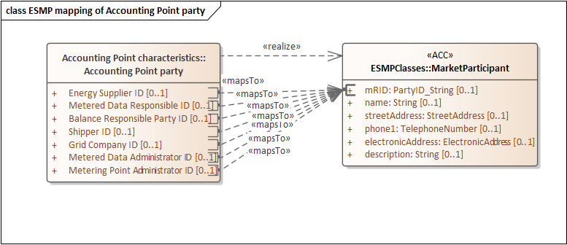
Figure 9 Mapping of Accounting Point party class from ebIX® to ESMP

Mapping table incl. MR proposals
ebIX® attribute | CIM attribute | ESMP attribute | MR / Comment
Energy Supplier ID | IEC62325/ MarketCommon/ MarketParticipant/ mRID | IEC62325-351/ ESMPClases/ MarketParticipant/ mRID
Metered Data Responsible ID | IEC62325/ MarketCommon/ MarketParticipant/ mRID | IEC62325-351/ ESMPClases/ MarketParticipant/ mRID
Balance Responsible Party ID | IEC62325/ MarketCommon/ MarketParticipant/ mRID | IEC62325-351/ ESMPClases/ MarketParticipant/ mRID
Shipper ID | IEC62325/ MarketCommon/ MarketParticipant/ mRID | IEC62325-351/ ESMPClases/ MarketParticipant/ mRID
Grid Company ID | IEC62325/ MarketCommon/ MarketParticipant/ mRID | IEC62325-351/ ESMPClases/ MarketParticipant/ mRID
Metered Data Administrator ID | IEC62325/ MarketCommon/ MarketParticipant/ mRID | IEC62325-351/ ESMPClases/ MarketParticipant/ mRID
Metering Point Administrator ID | IEC62325/ MarketCommon/ MarketParticipant/ mRID | IEC62325-351/ ESMPClases/ MarketParticipant/ mRID

Candidates for MRs:
- No MRs needed.

Mapping of Customer class from ebIX® to CIM

Class diagram: Mapping to basic CIM
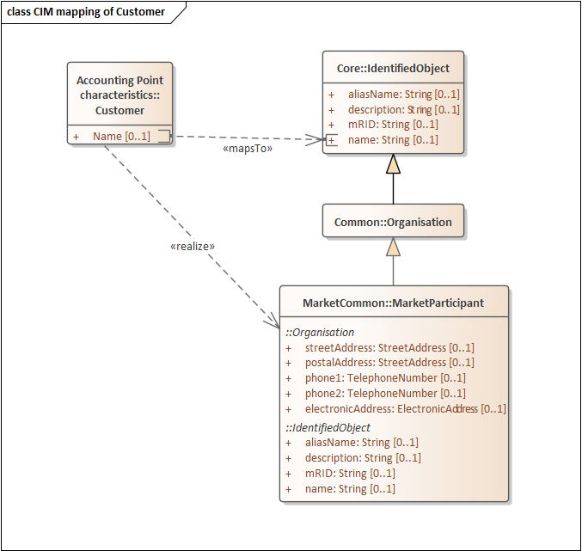
Figure 10 Mapping of Customer class from ebIX® to basic CIM

Class diagram: Mapping to basic ESMP
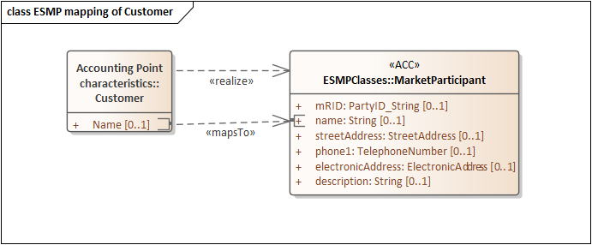
Figure 11 Mapping of Customer class from ebIX® to ESMP

Mapping table incl. MR proposals
ebIX® attribute | CIM attribute | ESMP attribute | MR / Comment
Name | IEC62325/ MarketCommon/ MarketParticipant/ name | IEC62325-351/ ESMPClases/ MarketParticipant/ name

Candidates for MRs:
- No MRs needed.

Mapping of Customer identification class from ebIX® to CIM

Class diagram: Mapping to basic CIM
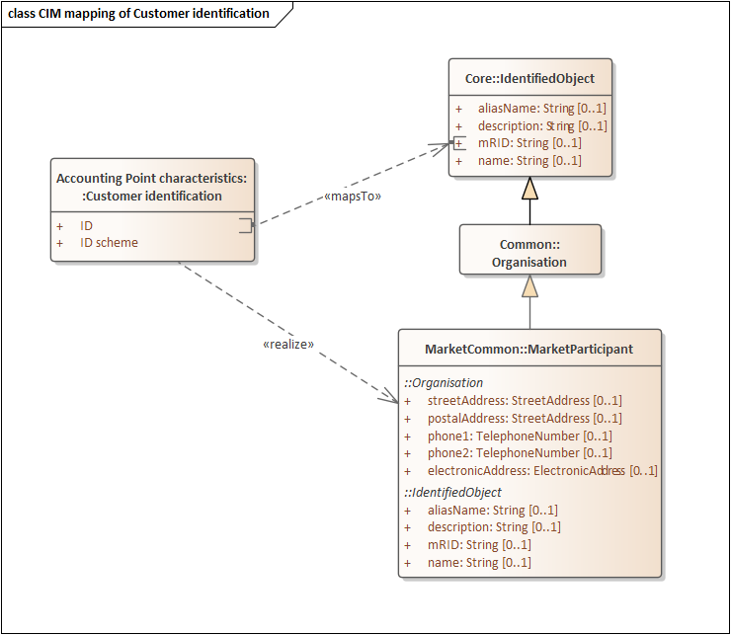
Figure 12 Mapping of Customer identification class from ebIX® to basic CIM

Class diagram: Mapping to basic ESMP
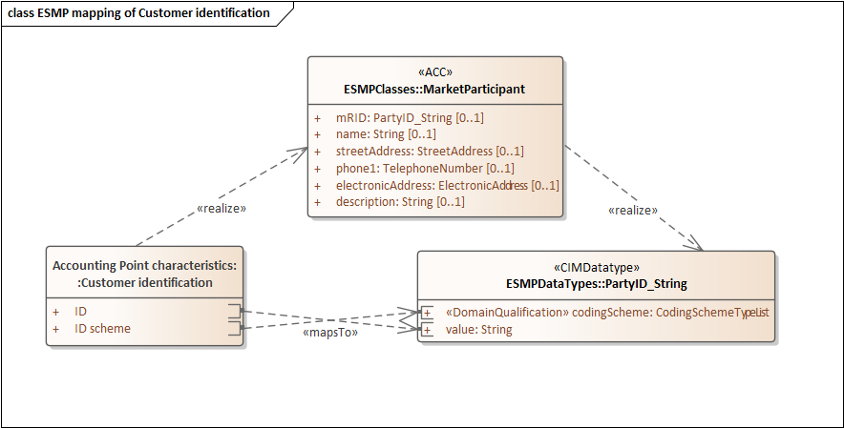
Figure 13 Mapping of Customer identification class from ebIX® to ESMP

Mapping table incl. MR proposals
ebIX® attribute | CIM attribute | ESMP attribute | MR / Comment
ID | IEC62325/ MarketCommon/ MarketParticipant/ mRID | IEC62325-351/ ESMPClases/ MarketParticipant/ mRID: PartyID_String/ value
ID scheme |  | IEC62325-351/ ESMPClases/ MarketParticipant/ mRID: PartyID_String/ codingScheme | The mRID attribute in IEC62325/ MarketCommon/ MarketParticipant/ is of type String, hence no ID scheme available. However, when mapped to ESMP the mRID is restricted to the datatype PartyID_String, which contain a “codingScheme”.

Candidates for MRs:
- No MRs needed.

Mapping of AP physical characteristics class from ebIX® to CIM

Class diagram: Mapping to basic CIM
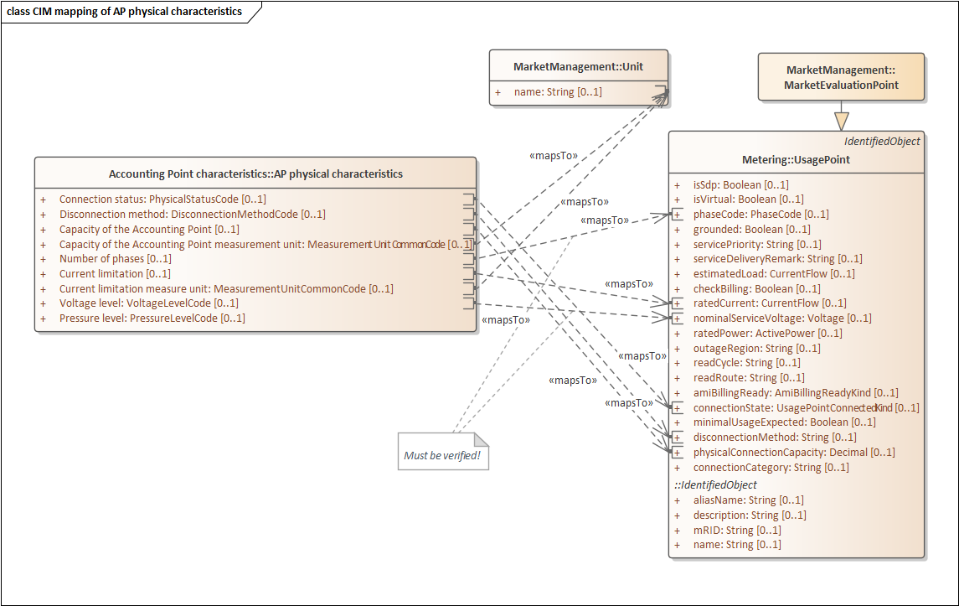
Figure 14 Mapping of AP physical characteristics class from ebIX® to basic CIM

Class diagram: Mapping to basic ESMP
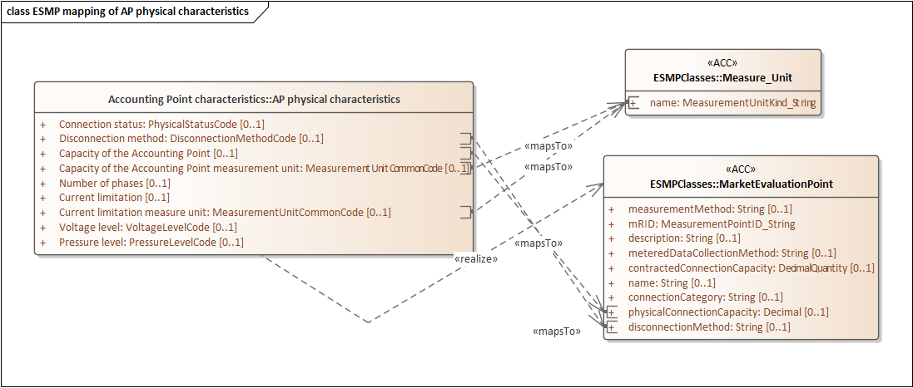 Figure 15 Mapping of AP physical characteristics class from ebIX® to ESMP

Mapping table incl. MR proposals
ebIX® attribute | CIM attribute | ESMP attribute | MR / Comment
Connection status | IEC61968/ Metering/ UsagePoint/ connectionState |  | Addition of the connectionState attribute to the MarketEvaluationPoint in IEC 62325-351 has already been asked for in ebIX® MR 2022/017. The MR was agreed in the CIM for retail market wg November 16th, 2022, but with a comment that it needs discussion in WG16.
Disconnection method | IEC61968/ Metering/ UsagePoint/ disconnectionMethod | IEC62325-351/ ESMPClases/ MarketEvaluationPoint/ disconnectionMethod
Capacity of the Accounting Point | IEC61968/ Metering/ UsagePoint/ physicalConnectionCapacity | IEC62325-351/ ESMPClases/ Measure_Unit/ name
Capacity of the Accounting Point measure unit | IEC62325/ Metering/ MarketManagement/ Unit/ name | IEC62325-351/ ESMPClases/ MarketEvaluationPoint/ physicalConnectionCapacity | Addition of an association from MarketEvaluationPoint to Unit in IEC 62325-301 and to Measure_Unit in IEC 62325-351.  See also “Current limitation measure unit (below)” and “  Candidates for MRs:  - Addition of an association from MarketEvaluationPoint to Unit in IEC 62325-301 and to Measure_Unit in IEC 62325-351.  - See also paragraph 0”  - Addition of an “Current limitation” attribute to MarketEvaluationPoint.  - Can the issue be solved by adding the existing ratedCurrent attribute from IEC62325/ MarketManagement/ MarketEvaluationPoint (inherited from UsagePoint) (definition: “Current flow that this usage point is configured to deliver”)?  - Addition of an association from MarketEvaluationPoint to Unit in IEC 62325-301 and to Measure_Unit in IEC 62325-351.  - See also paragraph 0  - Addition of a “Voltage level” attribute to MarketEvaluationPoint.  - Can the issue be solved by adding the existing attribute nominalServiceVoltage attribute from IEC62325/ MarketManagement/ MarketEvaluationPoint (definition: “Nominal service voltage”)?  - Addition of a “pressureLevel” attribute to MarketEvaluationPoint, both in IEC 62325-301 and in IEC 62325-351.  Mapping of AP administrative characteristics class from ebIX® to CIM in paragraph 0”.
Number of phases | IEC61968/ Metering/ UsagePoint/ phaseCode |  | Mapping to basic CIM must be verified!  Addition of the phaseCode attribute to the MarketEvaluationPoint in IEC 62325-351 has already been asked for in ebIX® MR 2022/015. The MR was agreed in the CIM for retail market wg March 15, 2023, and submitted to WG16 March 16th, 2023.
Current limitation | IEC61968/ Metering/ UsagePoint/ ratedCurrent |  | Addition of an “Current limitation” attribute to MarketEvaluationPoint.  Can the issue be solved by adding the existing ratedCurrent attribute from IEC62325/ MarketManagement/ MarketEvaluationPoint (inherited from UsagePoint) (definition: “Current flow that this usage point is configured to deliver”)?
Current limitation measure unit | IEC62325/ Metering/ MarketManagement/ Unit/ name | IEC62325-351/ ESMPClases/ Measure_Unit/ name | Addition of an association from MarketEvaluationPoint to Unit in IEC 62325-301 and to Measure_Unit in IEC 62325-351.  See also paragraph 0”.
Voltage level | IEC61968/ Metering/ UsagePoint/ nominalServiceVoltage |  | Mapping to basic CIM must be verified!  Addition of a “Voltage level” attribute to MarketEvaluationPoint.  Can the issue be solved by adding the existing attribute nominalServiceVoltage attribute from IEC62325/ MarketManagement/ MarketEvaluationPoint (definition: “Nominal service voltage”)?
Pressure level |  |  | Addition of a “pressureLevel” attribute to MarketEvaluationPoint, both in IEC 62325-301 and in IEC 62325-351.

Candidates for MRs:
- Addition of an association from MarketEvaluationPoint to Unit in IEC 62325-301 and to Measure_Unit in IEC 62325-351.
- See also paragraph 0”
- Addition of an “Current limitation” attribute to MarketEvaluationPoint.
- Can the issue be solved by adding the existing ratedCurrent attribute from IEC62325/ MarketManagement/ MarketEvaluationPoint (inherited from UsagePoint) (definition: “Current flow that this usage point is configured to deliver”)?
- Addition of an association from MarketEvaluationPoint to Unit in IEC 62325-301 and to Measure_Unit in IEC 62325-351.
- See also paragraph 0
- Addition of a “Voltage level” attribute to MarketEvaluationPoint.
- Can the issue be solved by adding the existing attribute nominalServiceVoltage attribute from IEC62325/ MarketManagement/ MarketEvaluationPoint (definition: “Nominal service voltage”)?
- Addition of a “pressureLevel” attribute to MarketEvaluationPoint, both in IEC 62325-301 and in IEC 62325-351.

Mapping of AP administrative characteristics class from ebIX® to CIM

Class diagram: Mapping to basic CIM
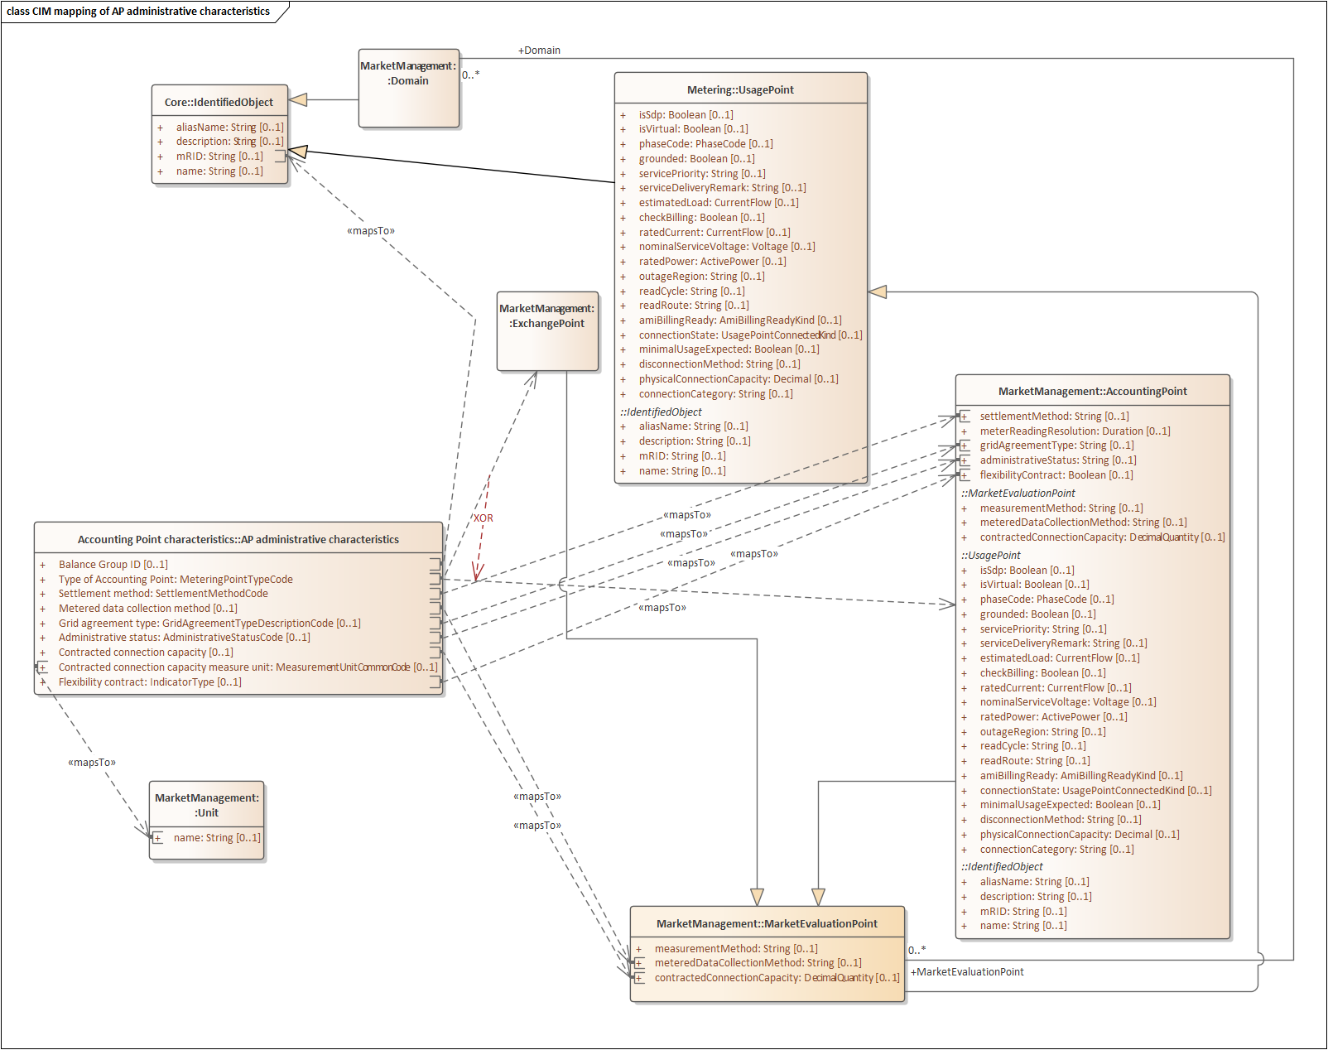
Figure 16 Mapping of AP administrative characteristics class from ebIX® to basic CIM

Class diagram: Mapping to basic ESMP
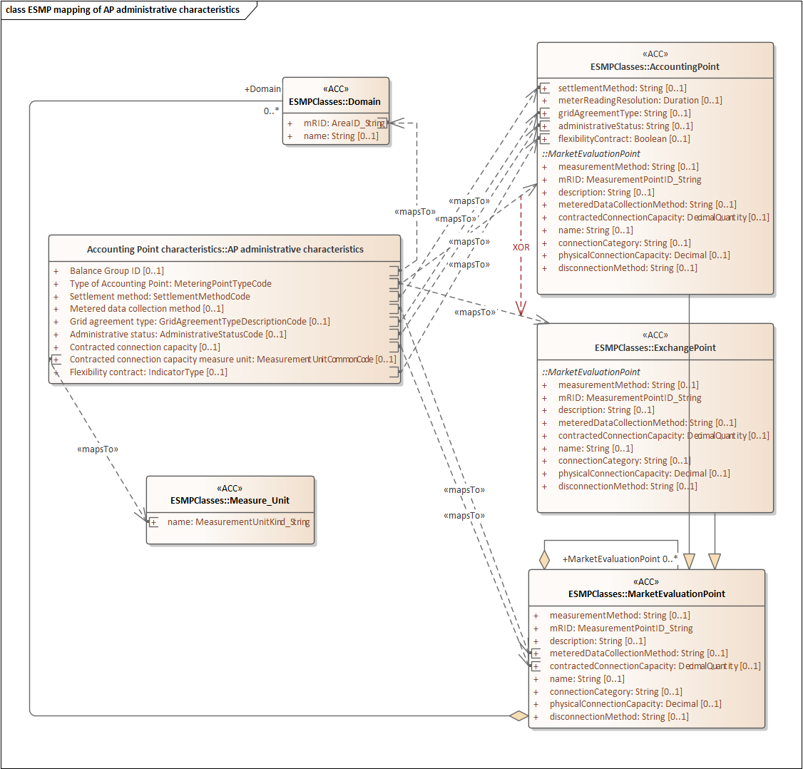
Figure 17 Mapping of AP administrative characteristics class from ebIX® to ESMP

Mapping table incl. MR proposals
ebIX® attribute | CIM attribute | ESMP attribute | MR / Comment
Balance Group ID | IEC62315/ MarketManagement/ Domain/ mRID | IEC62325-351/ ESMPClases/ Domain/ mRID
Type of Accounting Point | IEC62315/ MarketManagement/ Domain/ AccountingPoint  or  IEC62315/ MarketManagement/ Domain/ ExchangePoint | IEC62325-351/ ESMPClases/ AccountingPoint  or  IEC62325-351/ ESMPClases/ ExchangePoint
Settlement method | IEC62315/ MarketManagement/ Domain/ AccountingPoint/ settlementMethod | IEC62325-351/ ESMPClases/ Measure_Unit/ name
Metered data collection method | IEC62325/ MarketManagement/ MarketEvaluationPoint/ meteredDataCollectionMethod | IEC62325-351/ ESMPClases/ AccountingPoint/ meteredDataCollectionMethod
Grid agreement type | IEC62315/ MarketManagement/ Domain/ AccountingPoint/ gridAgreementType | IEC62325-351/ ESMPClases/ AccountingPoint/ gridAgreementType | Addition of the new datatype ESMPDataTypes/GridAgreementType_String and the new enumeration ESMPEnumerations GridAgreementTypeList to IEC 62325-351 (ESMP) has already been asked for in ebIX® MR 2022/030. The MR was resubmitted to CIM for retail market wg October 20th.
Administrative status | IEC62315/ MarketManagement/ Domain/ AccountingPoint/ administrativeStatus | IEC62325-351/ ESMPClases/ AccountingPoint/ administrativeStatus
Contracted connection capacity | IEC62325/ MarketManagement/ MarketEvaluationPoint/ contractedConnectionCapacity | IEC62325-351/ ESMPClases/ AccountingPoint/ contractedConnectionCapacity
Contracted connection capacity measure unit | IEC62325/ MarketManagement/ Unit/ name | IEC62325-351/ ESMPClases/ Measure_Unit/ name | Addition of an association from MarketEvaluationPoint to Unit in IEC 62325-301 and to Measure_Unit in IEC 62325-351.  See also “Mapping of AP physical characteristics class from ebIX® to CIM  Candidates for MRs:  - Addition of an association from MarketEvaluationPoint to Unit in IEC 62325-301 and to Measure_Unit in IEC 62325-351.  - See also paragraph 0”  - Addition of an “Current limitation” attribute to MarketEvaluationPoint.  - Can the issue be solved by adding the existing ratedCurrent attribute from IEC62325/ MarketManagement/ MarketEvaluationPoint (inherited from UsagePoint) (definition: “Current flow that this usage point is configured to deliver”)?  - Addition of an association from MarketEvaluationPoint to Unit in IEC 62325-301 and to Measure_Unit in IEC 62325-351.  - See also paragraph 0  - Addition of a “Voltage level” attribute to MarketEvaluationPoint.  - Can the issue be solved by adding the existing attribute nominalServiceVoltage attribute from IEC62325/ MarketManagement/ MarketEvaluationPoint (definition: “Nominal service voltage”)?  - Addition of a “pressureLevel” attribute to MarketEvaluationPoint, both in IEC 62325-301 and in IEC 62325-351.  Mapping of AP administrative characteristics class from ebIX® to CIM”.
Flexibility contract | IEC62315/ MarketManagement/ Domain/ AccountingPoint/ flexibilityContract | IEC62325-351/ ESMPClases/ AccountingPoint/ flexibilityContract

Candidates for MRs:
- Addition of an association from MarketEvaluationPoint to Unit in IEC 62325-301 and to Measure_Unit in IEC 62325-351.
- See also paragraph 9

Mapping of Metering Grid Area class from ebIX® to CIM

Class diagram: Mapping to basic CIM
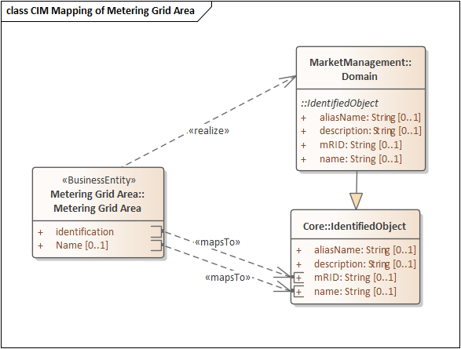
Figure 18 Mapping of Metering Grid Area class from ebIX® to basic CIM

Class diagram: Mapping to basic ESMP
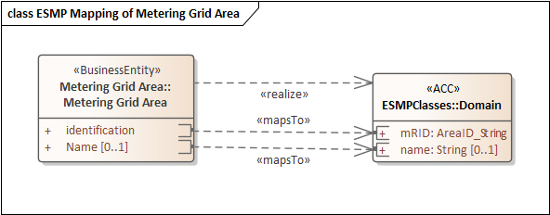
Figure 19 Mapping of Metering Grid Area class from ebIX® to ESMP

Mapping table incl. MR proposals
ebIX® attribute | CIM attribute | ESMP attribute | MR / Comment
Identification | IEC62325/ MarketManagement/ Domain/ mRID | IEC62325-351/ ESMPClases/ Domain/ mRID
Snapshot date | IEC62315/ MarketManagement/ Domain/ name | IEC62325-351/ ESMPClases/ Domain/ name

Candidates for MRs:
- No MRs needed.

Mapping of Aggregated Reception Station class from ebIX® to CIM

Class diagram: Mapping to basic CIM
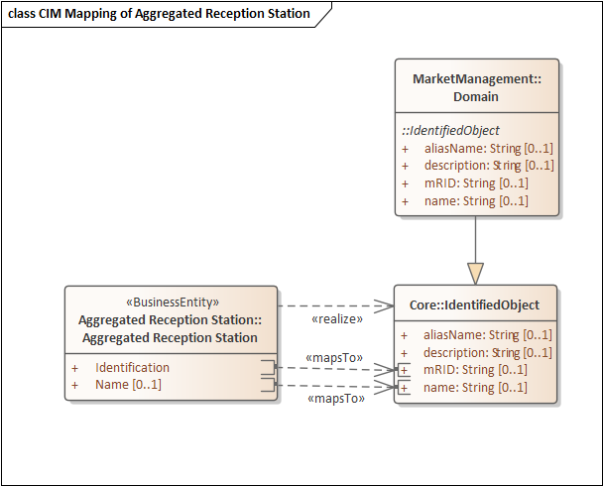
Figure 20 Mapping of Aggregated Reception Station class from ebIX® to basic CIM

Class diagram: Mapping to basic ESMP
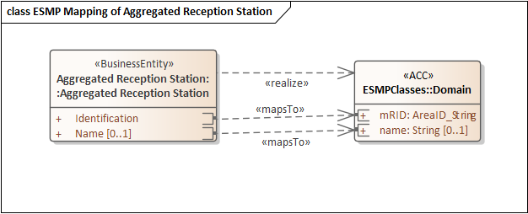
Figure 21 Mapping of Aggregated Reception Station class from ebIX® to ESMP

Mapping table incl. MR proposals
ebIX® attribute | CIM attribute | ESMP attribute | MR / Comment
Identification | IEC62325/ MarketManagement/ Domain/ mRID | IEC62325-351/ ESMPClases/ Domain/ mRID
Snapshot date | IEC62315/ MarketManagement/ Domain/ name | IEC62325-351/ ESMPClases/ Domain/ name

Candidates for MRs:
- No MRs needed.

Mapping of Calorific Value Area class from ebIX® to CIM

Class diagram: Mapping to basic CIM
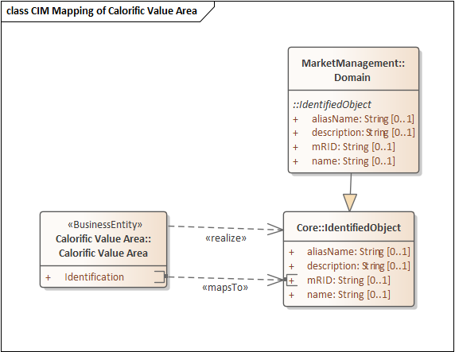
Figure 22 Mapping of Calorific Value Area class from ebIX® to basic CIM

Class diagram: Mapping to basic ESMP
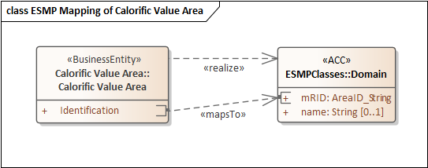
Figure 23 Mapping of Calorific Value Area class from ebIX® to ESMP

ebIX® attribute | CIM attribute | ESMP attribute | MR / Comment
Identification | IEC62325/ MarketManagement/ Domain/ mRID | IEC62325-351/ ESMPClases/ Domain/ mRID
Snapshot date | IEC62315/ MarketManagement/ Domain/ name | IEC62325-351/ ESMPClases/ Domain/ name

Candidates for MRs:
- No MRs needed.

Mapping of Energy label class from ebIX® to CIM

Class diagram: Mapping to basic CIM
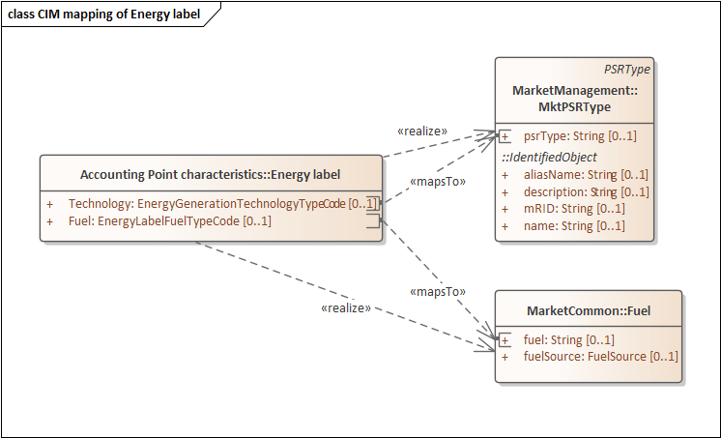
Figure 24 Mapping of Energy label class from ebIX® to basic CIM

Class diagram: Mapping to basic ESMP
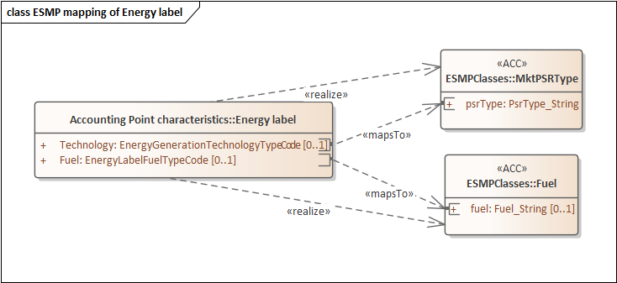
Figure 25 Mapping of Energy label class from ebIX® to ESMP

Mapping table incl. MR proposals
ebIX® attribute | CIM attribute | ESMP attribute | MR / Comment
Technology | IEC62325/ MarketManagement/ MktPSRType / psrType | IEC62325-351/ ESMPClases/ MktPSRType / psrType | We need addition of an association from AccountingPoint or MarketEvaluationPoint to MktPSRType in IEC 62325-351 and in IEC 62325-301.
Fuel | IEC62315/ MarketCommon / Fuel/ fuel | IEC62325-351/ ESMPClases/ Fuel/ fuel | We need addition of an association from AccountingPoint or MarketEvaluationPoint to Fuel in IEC 62325-351 and in IEC 62325-301.

Candidates for MRs:
- Add an association from AccountingPoint or MarketEvaluationPoint to MktPSRType in IEC 62325-351 and IEC 62325-301.
- Add an association from AccountingPoint or MarketEvaluationPoint to Fuel in IEC 62325-351 and IEC 62325-301.

Mapping of AP billing characteristics from ebIX® to CIM

Class diagram: Mapping to basic CIM
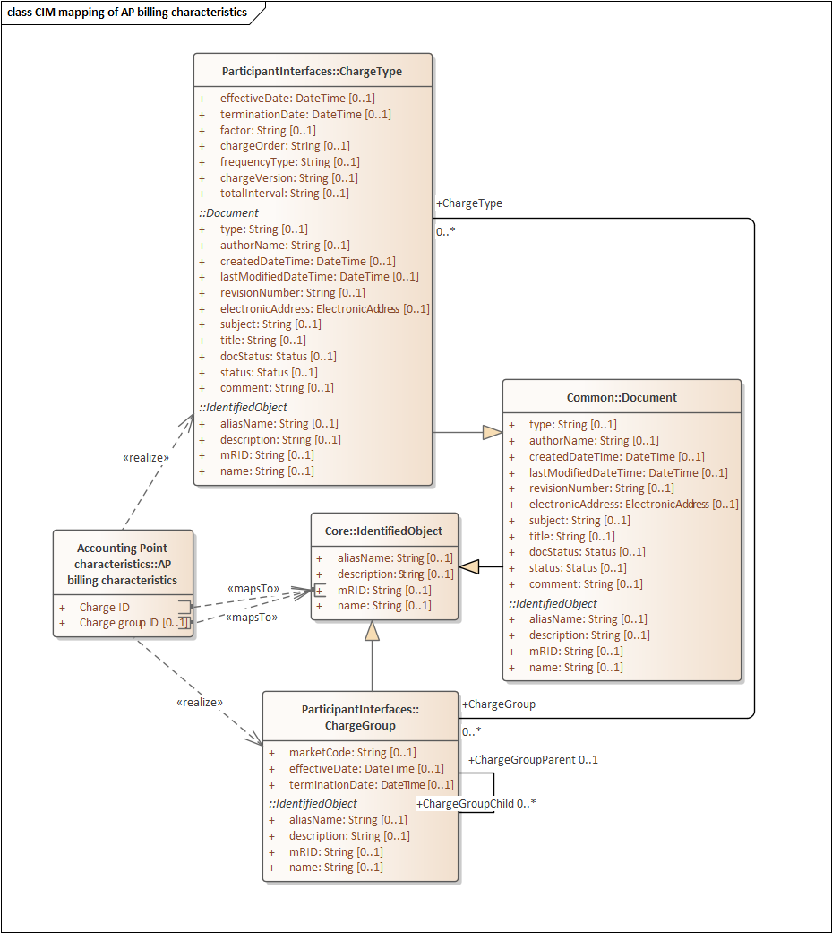
Figure 26 Mapping of AP billing characteristics class from ebIX® to basic CIM

Class diagram: Mapping to basic ESMP
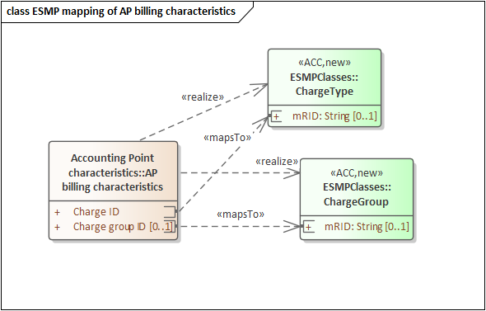
Figure 27 Mapping of AP billing characteristics class from ebIX® to ESMP

Mapping table incl. MR proposals
ebIX® attribute | CIM attribute | ESMP attribute | MR / Comment
Charge ID | IEC62325/ MarketOperations/ ParticipantInterfaces/ ChargeType/ mRID | IEC62325-351/ ESMPClases/ ChargeType/ mRID | The ChargeType class and related mRID is asked added to ESMP in ebIX® MR 2022/20. The MR is approved by CIM for retail market TF.
Charge group ID | IEC62325/ MarketOperations/ ParticipantInterfaces/ ChargeGroup/ mRID | IEC62325-351/ ESMPClases/ ChargeGroup/ mRID | The ChargeGroup class, related mRID and association to ChargeType is asked added to ESMP in ebIX® MR 2022/24. The MR is approved by CIM for retail market TF.  An association from MktActivityRecord to ChargeGroup is asked for in ebIX® MR 2022/14. The MR is approved by CIM for retail market TF.

Candidates for MRs:
- Do we need an association from Accounting Point to ChargeGroup?

Mapping of Energy volume information class from ebIX® to CIM

Class diagram: Mapping to basic CIM
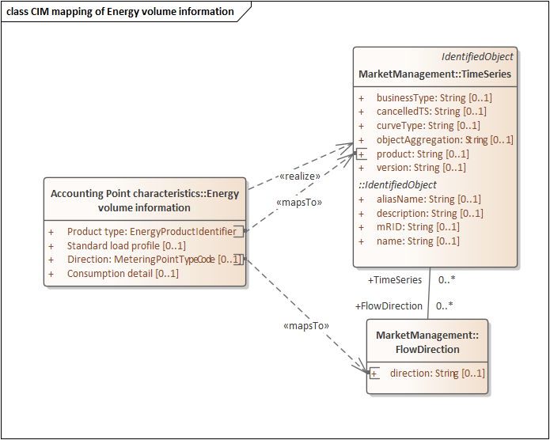
Figure 28 Mapping of Energy volume information class from ebIX® to basic CIM

Class diagram: Mapping to basic ESMP
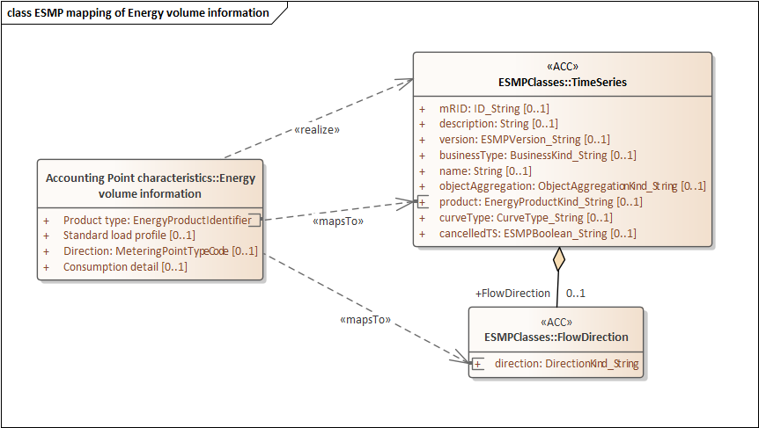
Figure 29 Mapping of Energy volume information class from ebIX® to ESMP

Mapping table incl. MR proposals
ebIX® attribute | CIM attribute | ESMP attribute | MR / Comment
Product type | IEC62325/ MarketManagement/ TimeSeries/ Product | IEC62325-351/ ESMPClases/ TimeSeries/ Product
Standard load profile |  |  | TBD
Direction | IEC62315/ MarketManagement/ FlowDirection/ direction | IEC62325-351/ ESMPClases/ FlowDirection/ direction
Consumption detail |  |  | TBD

Candidates for MRs:
- We need MR for Standard load profile (the standard load profile for this Metering Point).
- We need MR for Consumption detail (An indication of the kind of consumption at this Accounting Point, such as production unit’s own consumption, pumped or disconnectable consumption).

Mapping of Estimated annual volume class from ebIX® to CIM

Class diagram: Mapping to basic CIM
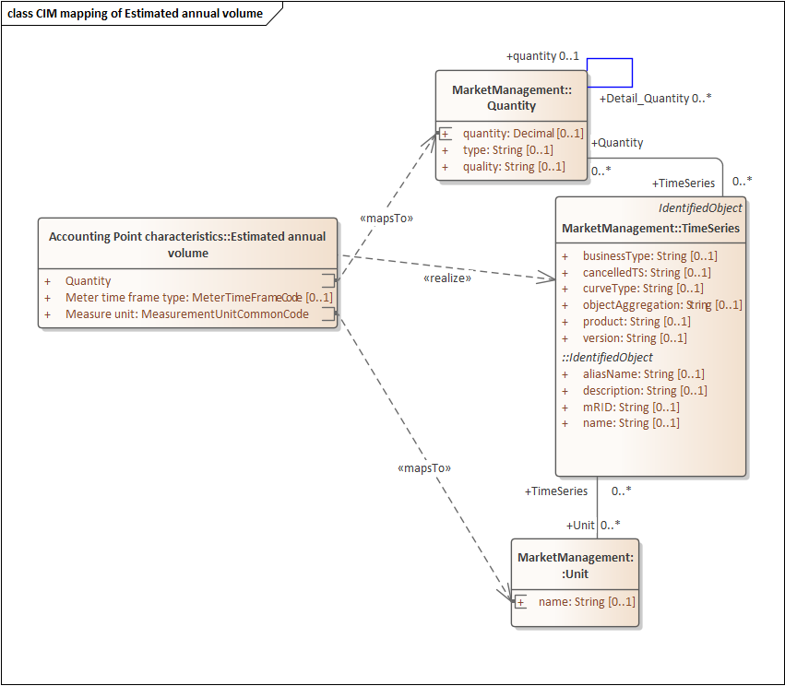
Figure 30 Mapping of Estimated annual volume class from ebIX® to basic CIM

Class diagram: Mapping to basic ESMP
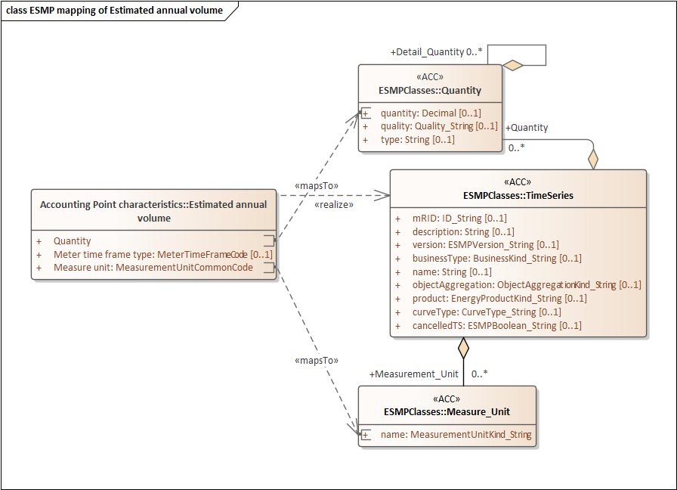
Figure 31 Mapping of Estimated annual volume class from ebIX® to ESMP

Mapping table incl. MR proposals
ebIX® attribute | CIM attribute | ESMP attribute | MR / Comment
Quantity | IEC62325/ MarketManagement/ Quantity/ quantity | IEC62325-351/ ESMPClases/ Quantity/ quantity
Meter time frame type |  |  | TBD
Measure unit | IEC62315/ MarketManagement/ Unit/ name | IEC62325-351/ ESMPClases/ AccountingPoint/ Unit

Candidates for MRs:
- We need MR for Meter time frame type (A code specifying the tariff time frame for this estimated annual volume).

Mapping of AP Measurement characteristics class from ebIX® to CIM

Class diagram: Mapping to basic CIM
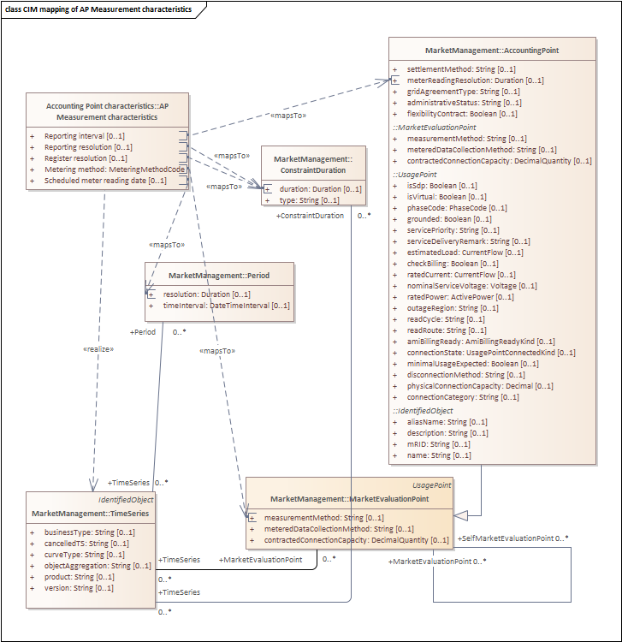
Figure 32 Mapping of Measurement characteristics class from ebIX® to basic CIM

Class diagram: Mapping to basic ESMP
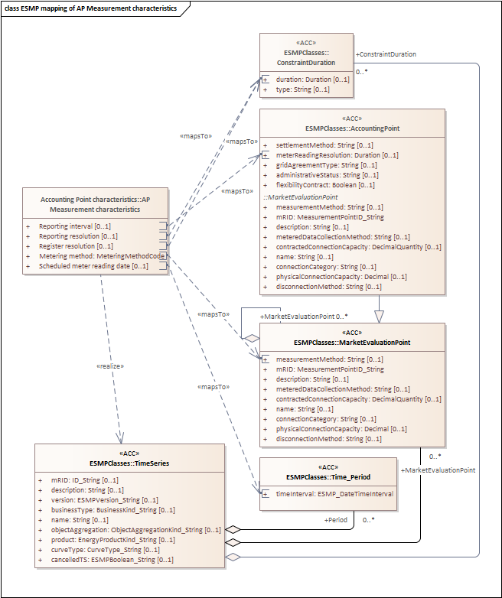
Figure 33 Mapping of AP Measurement characteristics class from ebIX® to ESMP

Mapping table incl. MR proposals
ebIX® attribute | CIM attribute | ESMP attribute | MR / Comment
Reporting interval | IEC62325/ MarketManagement/ AccountingPoint/ meterReadingResolution | IEC62325-351/ ESMPClases/ AccountingPoint/ meterReadingResolution
Reporting resolution | IEC62315/ MarketManagement/ ConstraintDuration / duration | IEC62325-351/ ESMPClases/ ConstraintDuration / duration
Register resolution | IEC62315/ MarketManagement/ ConstraintDuration / duration | IEC62325-351/ ESMPClases/ ConstraintDuration / duration
Metering method | IEC62315/ MarketManagement/ MarketEvaluationPoint/ measurementMethod | IEC62325-351/ ESMPClases/ MarketEvaluationPoint/ measurementMethod
Scheduled meter reading date | IEC62315/ MarketManagement / Period/ resolution | IEC62325-351/ ESMPClases/ Time_Period/ resolution

Candidates for MRs:
- No MRs needed.

It is assumed that Accounting Points are uniquely dedicated to either electricity or to gas.
The Building Number may include a “Building Number Extension”, such as one or more character making the address unique.
The altitude of the meter may be used in the gas sector for correction purposes.
A profiled Accounting Point is always a part of the reconciliation process as opposed to non-profiled.
The definition is simplified version of the definition in the ebIX®, EFET and ENTSO-E Harmonised Role model [3].
The altitude of the meter may be used in the gas sector for correction purposes.

