Content
1 Introduction 1
2 Metering configuration characteristics class diagram 2
2.1 Element definitions from ebIX®: Metering configuration characteristics 3
3 Mapping of Metering configuration characteristics class from ebIX® to CIM 9
4 Mapping of Meter class from ebIX® to CIM 10
5 Mapping of Gateway class from ebIX® to CIM 13
6 Mapping of Conversion factor class from ebIX® to CIM 15
7 Mapping of Placement information class from ebIX® to CIM 16
8 Mapping of Meter address class from ebIX® to CIM 17
9 Mapping of Geographical coordinate class from ebIX® to CIM 18
10 Mapping of Register class from ebIX® to CIM 19

Introduction
This document shows a proposal how to map the Metering configuration characteristics class diagram, found in the ebIX® BRS for Alignment of metering configuration characteristics for a Metering Point, to CIM.

Metering configuration characteristics class diagram
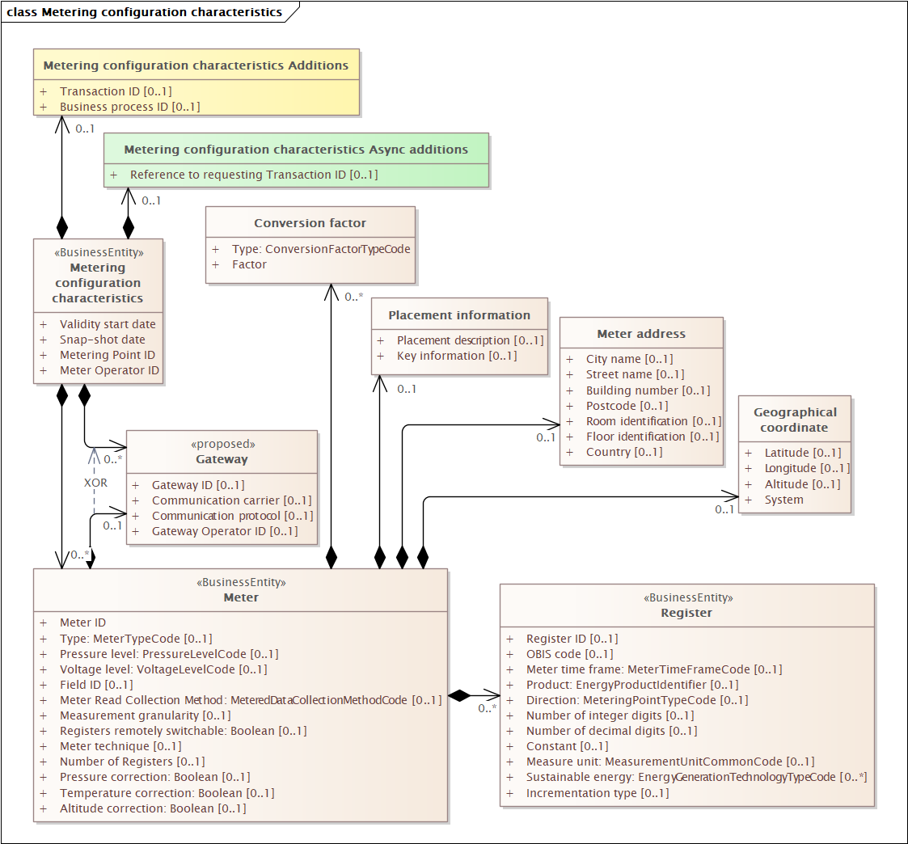
Figure 1 Metering configuration characteristics class diagram from ebIX® BRS for Metering configuration characteristics

Element definitions from ebIX®: Metering configuration characteristics
Class/attribute | Sector | Description
«Business entity»  Metering configuration characteristics |  | The information set of metering configuration characteristics of a Metering Point sent by the Meter Administrator to the Entitled Party in response to a request or when notifying metering configuration characteristics after a change in the characteristics.  Entitled Parties:  - Consented Party  - Meter Operator  - Metered Data Collector  - Metered Data Responsible
Validity start date |  | The date when the set of metering configuration characteristics for this Metering Point in this business document becomes or became valid.
Snapshot date |  | The date and time when the set of information was extracted from the Meter administration.
Metering Point ID |  | The unique identification of the Metering Point of this metering configuration.
Meter Operator ID |  | The identification of the Meter Operator for this Meter at this Metering Point, which is the party responsible for installing, maintaining, testing, certifying and physically decommissioning this Meter.
«Business entity»  Meter |  | A physical device containing one or more registers.
Meter ID |  | The unique identification of the Meter.
Type |  | A code representing the type of the Meter.  E01 Electronic  E02 Analog  E03 Advanced - Smart
Pressure level | Gas | The Pressure level at which the Meter operates at this Metering Point.  Dependency:  - Required if different from “standard low national distribution pressure”.
Voltage level | Elec. | The Voltage level at which the Meter operates at this Metering Point.  Dependency:  - Required if different from “standard low distribution voltage (230V/400V)”
Field ID |  | The unique identification of the Field (as part of the physical Connection of this Metering Point) where this Meter is installed. A Field is a physical entity connecting a Grid to the Installation belonging to a Party Connected to Grid. The Field may contain active objects, such as Transformers, Meters and Fuses.  The Field is sometimes referred to as (measure) street in Gas sector, or bay in the electricity sector.  Dependency:  - Only used for complex installations.
Meter read collection method |  | Indication of the way the Meter is read and thereby indicating the corresponding functionality to access reads.  Dependency:  - Dependent on national rules.
Measurement granularity |  | The actual measurement intervals of the Meter, such as 15 minutes or monthly.  Dependency:  - Dependent on national rules.
Registers remotely switchable | Elec | Indication that the Meter is remotely switchable between the registers, for example by a tone frequency receiver.  Dependency:  - Dependent on national rules.
Meter technique |  | A code indicating what kind of technique is used in the Meter.  Dependency:  - Dependent on national rules.
Number of Registers |  | Number of Registers available in the Meter.
Pressure correction | Gas | Indication whether the Meter corrects measured values for pressure or not.  Dependency:  - Dependent on national rules.
Temperature correction | Gas | Indication whether the Meter corrects measured values for the temperature or not.  Dependency:  - Dependent on national rules.
Altitude correction | Gas | Indication whether the Meter corrects the measured values for altitude or not.  Dependency:  - Dependent on national rules.
Conversion factor |  | A value that specifies a conversion factor for this specific Metering configuration, such as for voltage, current, pressure, temperature. There can be more than one Factor of each Type for a Meter, but only one of each Type.
Type |  | A code representing the type of Conversion Factor.
Factor |  | The conversion factor used in the calculation of a volume from the reading of register(s) of this Meter.
Gateway |  | A communication device or service to exchange data between one or more physical equipment, and relevant market parties. It may have additional intelligent functions related to the exchange and/or the data.  Examples of intelligent functions:  Connection/disconnection, changing resolutions, handling time of use, multiplication of correction factors and other algorithms.  Examples of equipment;  Meters and Disconnector Switch.
Gateway ID |  | The unique identification of the Communication Gateway the metering configuration at this Metering Point is communicating through.
Communication carrier |  | The Type of carrier, such as PLC, wired or wireless, used to contact the Communication Gateway.
Communication protocol |  | The Type of communication protocol used by this Communication Gateway.
Gateway Operator ID |  | The identification of the Gateway Operator responsible for this Communication Gateway.
Meter address |  | The physical address where this Meter is located.  Dependency:  - Dependent on national rules.
City Name |  | The name, expressed as text, of the city, town or village of this address.
Street Name |  | The name, expressed as text, of this street or thoroughfare of this address.
Building Number |  | The number, expressed as text, of the building or house on this street at this address.
Postcode |  | The code specifying the postcode of this address.
Room Identification |  | The identification, expressed as text, of the room, suite, office or apartment as part of this address.
Floor Identification |  | The identification by name or number, expressed as text, of the floor in the building as part of this address.
Country |  | The unique identifier of the country for this address (Reference ISO 3166 and UN/ECE Rec 3).
Geographical Coordinates |  | The set of geographical coordinates of the exact location of this Meter.  Dependency:  - Dependent on national rules
Latitude |  | The measure of the latitude as an angular distance north or south from the Equator meridian to the meridian of the location of this Meter for its geographical coordinate. (Reference ISO 6709).  Dependency:  - Must be used together with Longitude
Longitude |  | The measure of the longitude as an angular distance east or west from the Greenwich meridian to the meridian of the location of this Meter (Reference ISO 6709).  Dependency:  - Must be used together with Latitude
Altitude | Gas | The measure of the altitude that reflects the vertical elevation of this Meter above a surface for the geographical coordinate of the location of this Meter (Reference ISO 6709).
System |  | The unique identifier of the reference system used for measuring these geographical coordinates.
Placement Information |  | Information on how to physically get to the location of the installation where this Meter is installed.
Placement description |  | Textual description of the placement (where and how) of this Meter.
Key information |  | Textual description of how to get hold of key(s) to get access to this Meter.
<<Business Entity>>  Register |  | A physical or logical counter on this Meter, measuring energy products.  Dependency:  - At least one of Identification, OBIS Code, Meter Time Frame and/or Product must be present  - If no OBIS Code, the Product, Direction and Measure Unit are required
Register ID |  | The unique identification of the Register (at least unique within this Meter).
OBIS code |  | A coded string to indicate the function of this Register.  Dependency:  - Dependent on national rules
Meter time frame | Elec. | A code specifying the tariff time frame for this Register.
Product |  | A code specifying a type of product for the quantity measured by this register.
Direction |  | The direction of the measured energy flow, such as production, consumption or combined.
Number of integer digits |  | The number of digits in the log of this Register, without decimals.
Number of decimal digits |  | The number of decimals in the log of this Register.
Constant |  | The multiplication factor for this Register, used to calculate a metric volume or meter read for a meter reading.  Dependency:  - The constant is required if different from 1.
Measure unit |  | The unit of measure for this Register.
Sustainable energy |  | An indication of what kind of sustainable energy (in case of production at this Metering Pointy) is measured in this Register.  Dependency:  - Only used for Direction equal to production (E18) or combined (E19)  - Dependent on national rules.
Incrementation type |  | A code showing if this Register provides cumulative readings or volumes between two points in time. Dependency:  - Dependent on national rules.
Metering configuration characteristics Additions |  | Additional information related to these metering configuration characteristics, to be agreed on a national level.
Transaction ID |  | The unique identification of this set of information, given by the Meter Administrator.
Business process ID |  | The unique identification, given by the Meter Administrator, of this metering configuration characteristics process that this response is part of.
Metering configuration characteristics, Async Additions |  | Additional information related to these metering configuration characteristics, needed when using asynchronous communication.
Reference to requesting Transaction ID |  | A reference to the requesting business document, used in the responding business document in a business transaction.  Dependency:  - Only used when responding to a request.

Table 1 Element definitions from ebIX®: Metering configuration characteristics

Mapping of Metering configuration characteristics class from ebIX® to CIM
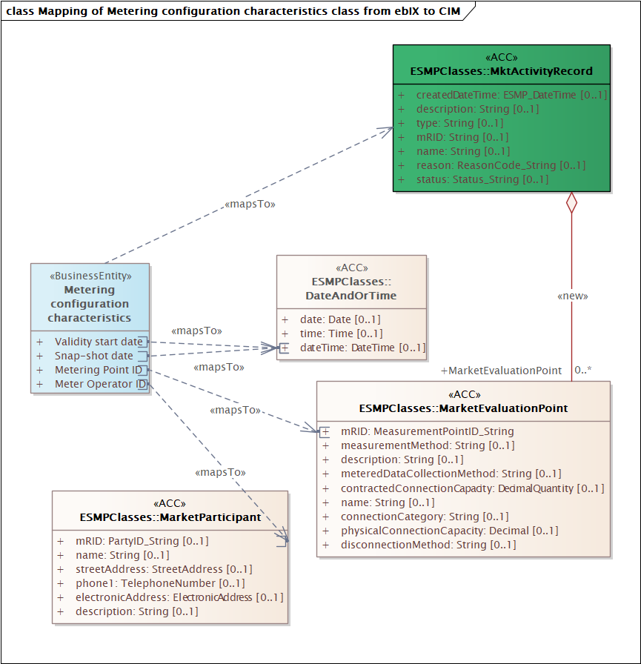
Figure 2 Mapping of Metering configuration characteristics class from ebIX® to CIM
Candidates for MRs:
- An association from MktActivityRecord to MarketEvaluationPoint is missing in IEC62325-351/ESMPClasses, however already available in basic CIM (but there is an association from MarketEvaluationPoint to MktActivityRecord – can MR 2022/012 have been implemented with wrong direction?).

Action (20230214):
- Jan (SE)/Kees will ask Alvaro to change the direction of the association from MarketEvaluationPoint to MktActivityRecord in ESMP, ref. MR 2022/012.

Mapping of Meter class from ebIX® to CIM
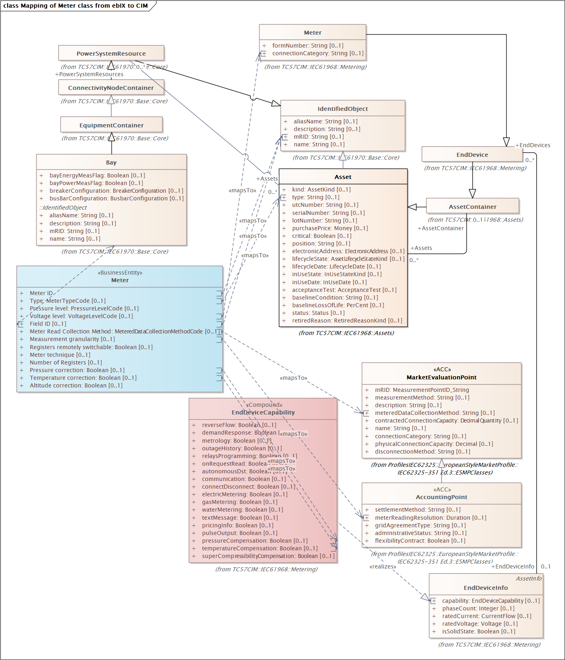
Figure 3 Mapping of Meter class from ebIX® to CIM

Candidates for MRs:
- Meter class:
Action (20230214): We will make a MR for addition of the IEC61968/Metering/Meter class to IEC62325-351/ESMPClasses, incl. mRID.
MR 2023/002 (add Meter to ESMP and add association between MarketEvaluationPoint and Meter)
- Meter ID: maps to mRID in IEC61968/Metering/Meter/mRID
Action (20230214): We will make a MR for addition of the mRID to the new Meter class in IEC62325-351/ESMPClasses, see also above.
MR 2023/002 (add Meter to ESMP and add association between MarketEvaluationPoint and Meter)
- Type: (electronic, analog or smart) maps to mRID in IEC61968/Metering/Meter/type
Action (20230214): We will make a MR for addition of the type to the new Meter class in IEC62325-351/ESMPClasses.
MR 2023/003 (add the attribute "type" to the Meter class in ESMP)
- Pressure level – We suggest using the same CIM attribute as for voltageLevel, i.e. IEC61968/Metering/Meter/ connectionCategory (“A code used to specify the connection category, e.g. low voltage, where the meter operates”)?
- VoltageLevel is suggested added as new an attribute to the IEC61968/Metering/UsagePoint class by the TR. However, it might fit well into the already existing Meter/connectionCategory (definition: “A code used to specify the connection category, e.g. low voltage, where the meter operates”).
Action( 20230214): We will make a MR for addition of the connectionCategory to the new Meter class in IEC62325-351/ESMPClasses.
MR 2023/004 (add connectionCategory to Meter in ESMP)
- Field ID (The unique identification of the Field (as part of the Connection) where this Meter is installed. A Field is a physical entity connecting a Grid to the Installation belonging to a Party Connected to Grid. The Field contains objects, such as Transformers, Meters and Fuses. The field is sometimes referred to as (measure) street in Gas sector, or Bay in the electricity sector.).
There is already an association between IEC61968/Metering/Meter and IEC61970/Base/Core/Bay and Meter (Asset has an association with PowerSystemResource that is inherited to Meter and Bay).
We suggest using the mRID in Bay for the Field ID.
Action (20230214): We will make a MR for addition of the IEC61970/Base/Core/Bay to IEC62325-351/ESMPClasses, including the mRID attribute and the related association between Meter and Bay.
MR 2023/005 (add Bay to ESMP and add an association from Meter to Bay)
- Meter Read Collection Method is already present as IEC62325-351/ESMPClasses/MarketEvaluationPoint/ meteredDataCollectionMethod
- Measurement granularity was originally requested in ebIX® MR 2019/007, Here it was called meterReadingPeriodicity but renamed to meterReadingResolution during the approval process. It has always been called Measurement granularity in the BRS for metering configuration characteristics (first published in 2016). The attribute is already present as IEC62325-351/ESMPClasses/AccountingPoint/meterReadingResolution
- Registers remotely switchable: Boolean (Indication that the Meter is remotely switchable between the registers, for example by a tone frequency receiver)
Suggestion: probably candidate for a new attribute in IEC61968/Metering/Meter.
Action (20230214): Ove will ask, Stefan, Joachim, Bostjan, Andrzej and Grazyna if the attribute is in uses (and needed for the future).
Answers:
  - Poland: Not used.
  - Germany: Today used by a tone frequency receiver. For the future Germany plan using it for special products of the supplier as additional to the normal regulated metering.
MR 2023/006 (add registersRemotelySwitchable to Meter in 61968 and ESMP)
- Meter technique (A code indicating what kind of technique is used in the Meter).
Suggestion: probably candidate for a new attribute in IEC61968/Metering/Meter.
Action (20230214): Ove will ask, Stefan, Joachim, Bostjan, Andrzej and Grazyna if the attribute is in use, and if used, how is it used?
Answers:
  - Poland: Plan to use Type of meter (smart or not smart) and Type of metering method (continuous (15 min. profile), registers or “no measurement” (type of AP without meters, energy consumption is estimated using contracted power)). However, these attributes are probably covered elsewhere.
  - Germany: Not used.
Conclusion:
  - No MR will be made unless anyone needs it.
- Number of Registers (Number of Registers available in the Meter).
Action (20230214): We will make a MR for addition of a new attribute, Number of Registers (Number of Registers available in the Meter), in IEC61968/Metering/Meter.
MR 2023/007 (add numberOfRegisters to Meter in 61968 and ESMP)
- Pressure correction: Boolean (Indication whether the Meter corrects measured values for pressure or not).
Action: We will make a MR for addition of IEC61968/Metering/EndDeviceInfo to IEC62325-351/ESMPClasses), including the attribute capability and the related IEC61968/Metering/«Compound» EndDeviceCapability/pressureCompensation (definition: True if device performs pressure compensation for metered quantities).
The MR will suggest redoing the CIM structure so that the addition is as an attribute not part of a compound.
MR 2023/008 (add pressureCorrection to Meter ESMP)
- Temperature correction: Boolean (Indication whether the Meter corrects measured values for the temperature or not).
Suggestion: Add IEC61968/Metering/EndDeviceInfo to IEC62325-351/ESMPClasses, including the attribute capability and the related IEC61968/Metering/«Compound» EndDeviceCapability/temperatureCompensation.
Action (20230214): We will make a MR for addition of IEC61968/Metering/EndDeviceInfo to IEC62325-351/ESMPClasses), including the attribute capability and the related IEC61968/Metering/«Compound» EndDeviceCapability/temperatureCompensation (definition: True if device performs temperature compensation for metered quantities.).
The MR will suggest redoing the CIM structure so that the addition is as an attribute not part of a compound.
MR 2023/009 (add temperatureCompensation to Meter ESMP)
- Altitude correction (Indication whether the Meter corrects the measured values for altitude or not).
Action (20230214): We will make a MR for addition of a new attribute altitudeCompensation in IEC61968/Metering/EndDeviceInfo.
MR 2023/010 (add altitudeCompensation to EndDeviceInfo ESMP)

Mapping of Gateway class from ebIX® to CIM
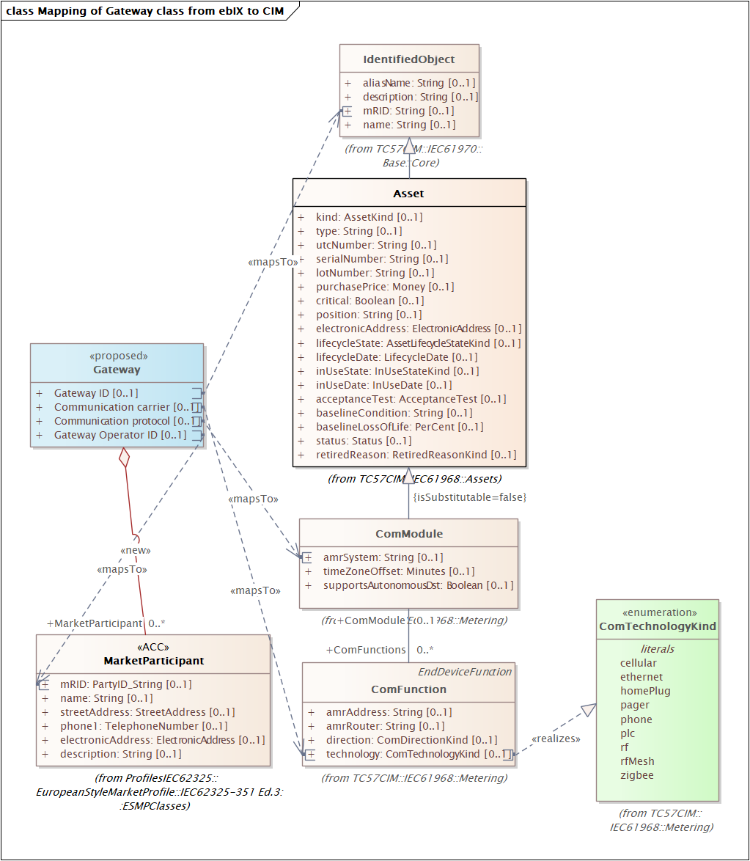
Figure 4 Mapping of Gateway class from ebIX® to CIM

Candidates for MRs:
- Gateway class:
Suggestion: Add the IEC61968/Metering/ComModule class to IEC62325-351/ESMPClasses, incl. mRID.
- Gateway ID: maps to mRID in IEC61968/Metering/ComModule/mRID
Suggestion: Add mRID to the new ComModule class in IEC62325-351/ESMPClasses.
- Communication carrier: (The Type of carrier, such as PLC, wired or wireless, used to contact the Communication Gateway).
Suggestion: Add IEC61968/Metering/ComFunction to IEC62325-351/ESMPClasses, including the attribute technology.
- Communication protocol: (The Type of communication protocol used by this Communication Gateway).
Suggestion: Add the amrSystem attribute to the new ComModule class in IEC62325-351/ESMPClasses, see item 1) above.
- Gateway Operator ID: Add an association from the new ComModule class in IEC62325-351/ESMPClasses (see item 1) above) to IEC62325-351/ESMPClasses/ MarketParticipant.
Action (20230214): Ove will ask Joachim and Vlatka if Gateway still is needed.
Answer from Vlatka:
  - Germany will need the Gateway also in the future. But I would wait with the MR until our national committee (DKE) has discussed that. They are preparing a CIM workshop in April, I will raise the question there.

Mapping of Conversion factor class from ebIX® to CIM
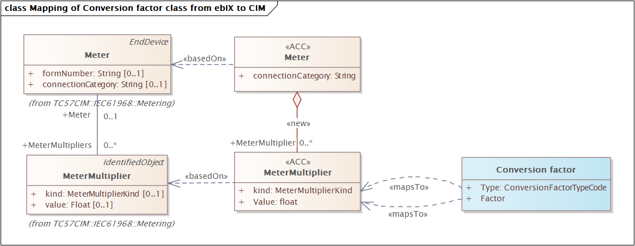
Figure 5 Mapping of Conversion factor class from ebIX® to CIM

Candidates for MRs:
- Conversion factor class:
Suggestion: Add the IEC61968/Metering/MeterMultiplier class to IEC62325-351/ESMPClasses, incl. the attributes kind and value, and add an association from Meter to MeterMultiplier in IEC62325-351/ ESMPClasses.
- Type: maps to IEC61968/Metering/MeterMultiplier/kind
- Factor: maps to IEC61968/Metering/MeterMultiplier/value
Action (20230214): Ove will ask EBG how to use the conversion factor, especially for temperature, pressure and measurement – and for electricity: is this the same as the constant in the register?

EBG discussed at their meeting April 25th and 26th how to use the conversion factor class in BRS for metering configuration characteristics, especially for temperature, pressure and measurement – and for electricity: is this the same as the constant in the register:
- The conversion factor for altitude is a multiplier that depends on the hight above sea-level.
- The conversion factor for pressure is a multiplier that depends on pressure at the measure point, e.g. due to measurements at the end of long pipes.
- The conversion factor for temperature is a multiplier that depends on the temperature.
- The conversion factor for measurements for gas is for example used when a smaller pipe is used for the measurement to be able to measure where the flow is lower, e.g. using a conversion factor of 20.
The conversion factor for measurements for electricity is used similar as for gas, e.g. measuring in a “bypass” with lower current, voltage etc. It is not the same as the constant for a register.

Action (20230515):
- Jan (SE) and Ove will ask EBG if we should add a link from Register to MeterMultiplier in the ebIX® BRS for Metering configuration characteristics.
Conclusion:
  - Not needed, since we already has the attribute Constant in the Register class.

Mapping of Placement information class from ebIX® to CIM
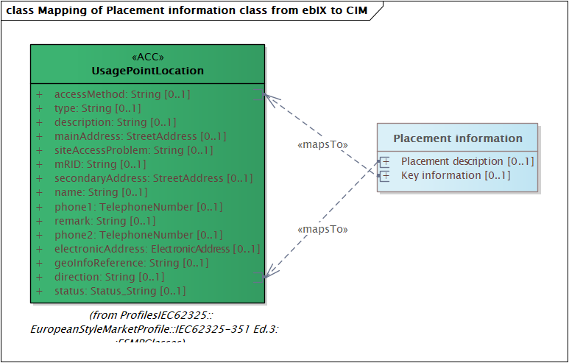
Figure 6 Mapping of Placement information class from ebIX® to CIM

Candidates for MRs:
- Placement information class:
Action (20230214): We will make a MR for addition of an association from Meter to UsagePointLocation (already existing in basic CIM).
- Placement description: Maps to direction in UsagePointLocation IEC62325-351/ESMPClasses, incl. the position attribute.
- Key information: Maps to accessMethod in UsagePointLocation IEC62325-351/ESMPClasses, incl. the position attribute.

Mapping of Meter address class from ebIX® to CIM
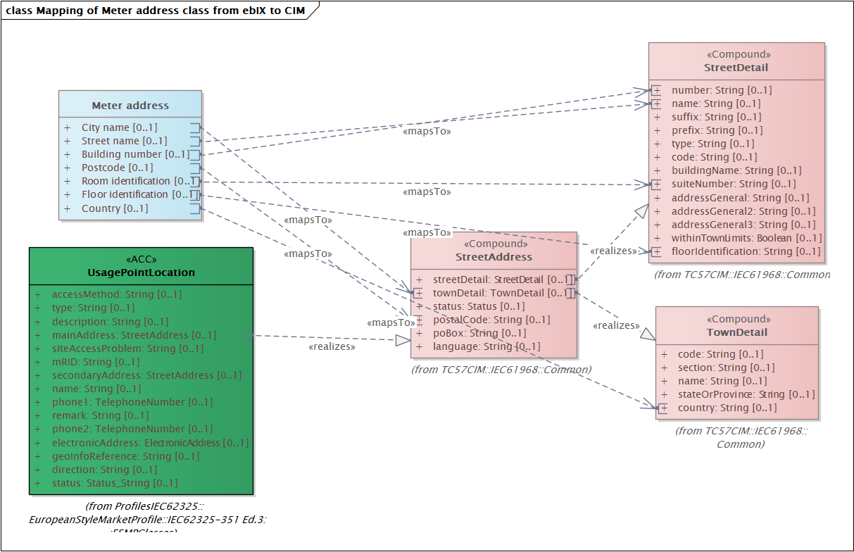
Figure 7 Mapping of Meter address class from ebIX® to CIM

No MR is needed:
- Meter address class: Maps to the existing Location class in IEC62325-351/ESMPClasses.
  - City name: maps to IEC61968/Common/«Compound» StreetAddress/townDetail.
  - Street name: maps to IEC61968/Common/«Compound» StreetAddress/StreetDetail/«Compound» StreetDetail/ name
  - Building number: maps to IEC61968/Common/«Compound» StreetAddress/StreetDetail/«Compound» StreetDetail/ number
  - Postcode: maps to IEC61968/Common/«Compound» StreetAddress/postalCode
  - Room identification: maps to IEC61968/Common/«Compound» StreetAddress/StreetDetail/ «Compound» StreetDetail/suiteNumber
  - Floor identification: maps to IEC61968/Common/«Compound» StreetAddress/StreetDetail/ «Compound» StreetDetail/floorIdentification
  - Country: maps to IEC61968/Common/«Compound» StreetAddress/townDetail/«Compound» TownDetail/country

Mapping of Geographical coordinate class from ebIX® to CIM
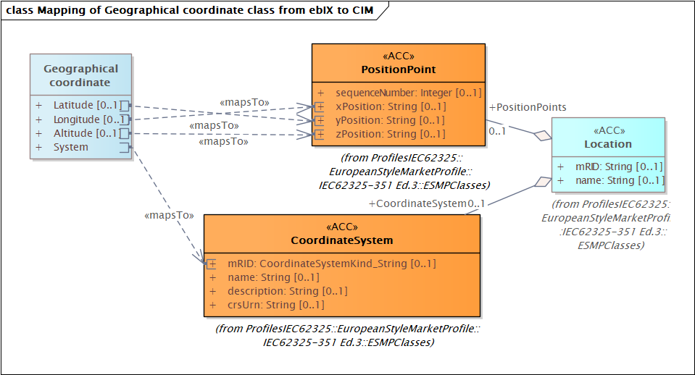 Figure 8 Mapping of Geographical coordinate class from ebIX® to CIM

No MR is needed:
- Geographical coordinate class: maps to PositionPoint and CoordinateSystem.

From Jan (SE):
We think the correct is using y-position for latitude and x-position for longitude. However, not everyone will agree… Let us look at CH1903 LV03 at https://coordinates-converter.com/en/info. The starting point of all calculations for Switzerland was fixed at Bern and is Y:600000 East | X:200000 North. Y is then longitude (east) and X is latitude (north).
Let us also look at https://www.lantmateriet.se/sv/geodata/gps-geodesi-och-swepos/Om-geodesi/Geodesitjanster/enkel-koordinattransformation/. At the bottom we read:
Plana koordinater till SWEREF 99 (WGS 84) [e.g. plane coordinates to SWEREF 99 (= WGS 84)] Koordinaterna (x, y eller N, E) skrivs i meter med eventuella decimaler.
[e.g. The coordinates (x, y or N, E) are written in meter with possible decimal places.] I.e. x is N(orth) and y is E(ast), x is then latitude and y is longitude.
See also here: https://spatialreference.org/ref/epsg/2393/html/ where (see bottom of page) X is North and Y is East.
Compare: https://gis.stackexchange.com/questions/99769/why-some-coordinate-systems-define-x-axis-as-northings-and-some-as-easting

My conclusion: Suggest changing the attributes in PositionPoint to longitude, latitude, altitude, but if not agreed, add explaining text to the description.
Action (20230215):
- Jan will ask WG16 if we should change the attributes in PositionPoint to longitude, latitude, altitude, but if not agreed, add explaining text to the description.

Mapping of Register class from ebIX® to CIM
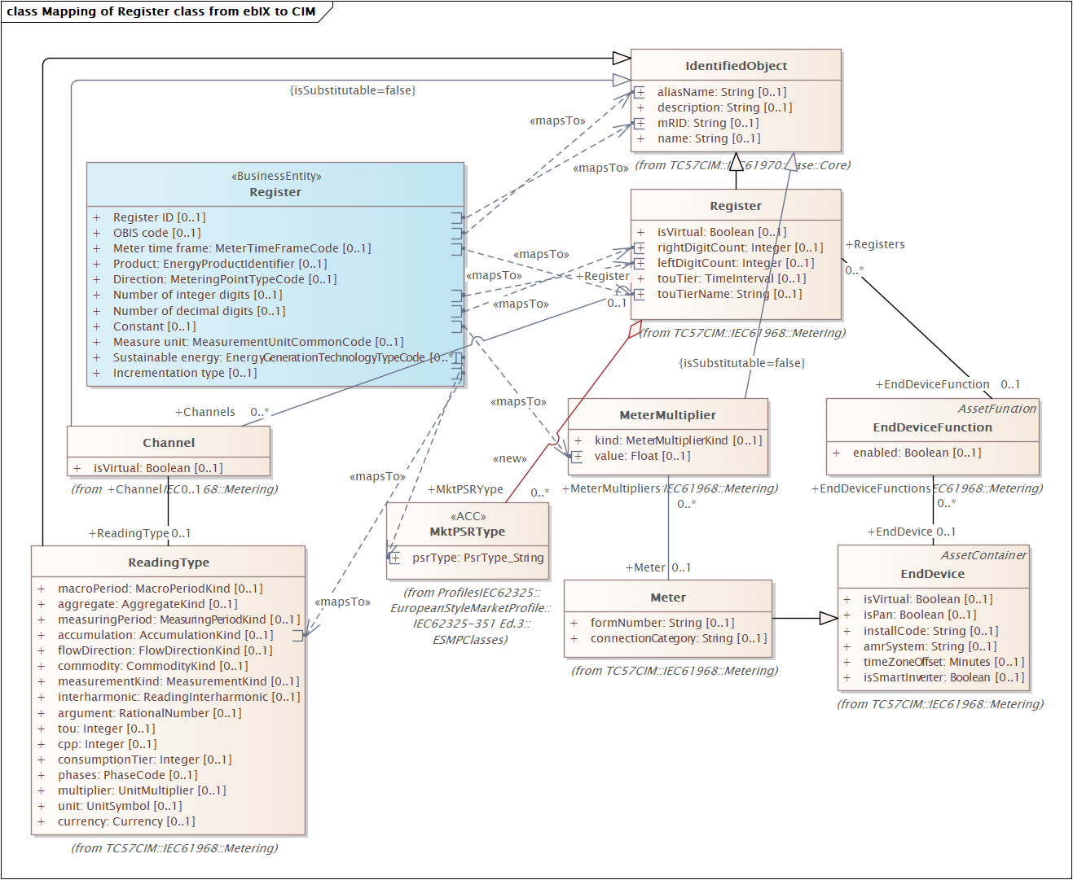
Figure 9 Mapping of Register class from ebIX® to CIM

Candidates for MRs:
- Register class:
Suggestion: Add the IEC61968/Metering/Register class to IEC62325-351/ESMPClasses, incl. the attributes mRID, aliasName and touTierName, and add an association from Meter to Register in IEC62325-351/ESMPClasses.
Conclusion:
  - Handled below
- OBIS code: maps to IEC61968/Metering/Register/aliasName.
Comments 20230515:
  - aliasName is proposed deprecated in CIM
  - We will not make any MR for the OBIS code for the time being.
- Register ID: maps to IEC61968/Metering/Register/mRID.
Comments 20230515:
  - Already in ESMP
- Meter time frame: maps to IEC61968/Metering/Register/touTierName.
Action 20230515:
  - Ove will make a MR for adding touTierName to Register in ESMP
Comments 20230515:
- Already in ESMP
- Product: maps to the new Product class suggested in ebIX® MR 2021/035 and the relation to Register maps to the association suggested in ebIX® MR 2021/044.
Action 20230516:
  - Jan (NL) will verify if ebIX® MR 2021/035 (new Product class) and ebIX® MR 2021/044 (Addition of association from Register to Product) still is valid.
- Direction: (The direction of the measured energy flow, such as production or consumption) should probably be mapped to a new energyFlowCategory attribute in IEC61968/Metering/Register, ref. ebIX® MR 2023/001 (addition of energyFlowCategory to AccountingPoint).
Suggestion: Add the attribute energyFlowCategory to the Register class.
Action 20230515:
  - Ove will make a MR for adding energyFlowCategory to Register in IEC/61968 and ESMP
- Number of integer digits: maps to IEC61968/Metering/Register/leftDigitCount.
- Number of decimal digits: maps to IEC61968/Metering/Register/rightDigitCount.
- Constant: May be mapped to IEC61968/Metering/MeterMultiplier class, however there is a long path from the IEC61968/Metering/Register class
Action 20230516:
  - The MeterMultiplier cannot be used
  - Ove will make a MR for adding a RegisterMultiplier linked to the Register. Similar as the MeterMultiplier class is linked to the Meter class.
- Measure unit: maps to the new attribute measureUnit in the new class Product, ref. item 5) above and new attribute measureUnit in the new Product class suggested in ebIX® MR 2021/035 (Product class) ebIX® MR 2021/036 (measureUnit attribute).to the IEC61968/Metering/MeterMultiplier class. The alternative is probably to add a new attribute Constand (or Multiplier) to the IEC61968/Metering/Register class.
Action 20230516:
  - Jan (NL) will verify if ebIX® MR 2021/035 (new Product class), ebIX® MR 2021/036 (measureUnit attribute) and ebIX® MR 2021/044 (Addition of association from Register to Product) still is valid.
- Sustainable energy: (An indication of what kind of sustainable energy (in case of production) is measured in this Register) should probably be mapped to the psrType attribute in IEC62325-351/ESMPClasses/MktPSRType.
Suggestion: Add an association between the IEC62325-351/ESMPClasses/MktPSRType class and the new IEC62325-351/ESMPClasses/Register class.
Action 20230516:
  - Ove will make a MR for adding an association from Register to MktPSRType in both IEC/62325 and ESMP.
- Incrementation type: maps to the IEC61968/Metering/ReadingType/Accumulation attribute.
Suggestion: Add the IEC61968/Metering/Channel and IEC61968/Metering/ReadingType classes to IEC62325-351/ESMPClasses, including the associations between the new Register class and the new Channel Class, and between the new Channel class and the ReadingType class in IEC62325-351/ESMPClasses.
It should be discussed if we could drop the addition of the Channel class to IEC62325-351/ESMPClasses.
Action 20230516:
  - Ove will make a MR for adding IEC61968/Metering/Channel and IEC61968/Metering/ReadingType classes to IEC62325-351/ESMPClasses, including the associations between the new Register class and the new Channel Class, and between the new Channel class and the ReadingType class in IEC62325-351/ESMPClasses.

It is assumed that Metering Points are uniquely dedicated to either electricity or to gas.
The number of Entitled Parties may be increased nationally, e.g. addition of Energy Supplier and Grid Company.
The Communication Gateway and Gateway Operator are not yet agreed added to the Harmonised Role Model [3];
Power Line Carrier - Legacy NB-PLC (BPSK, FSK, CHIRP) - IEC 61334 - NextGen NB-PLC (OFDM) - G3-PLC (ITU-T G.9903) - PRIME (ITU-T G9904) - IEEE 1901.2 Wireless communication - xG (Cellular Networks) - 2G (FDMA) - GSM - GPRS - EDGE - 3G (TDMA/CDMA) - UMTS - HSPA - HSPA+ - 4G (CDMA) - LTE (450MHz/800MHz/1800MHz/2,6GHz) - LTE Advanced - 5G (CDMA) - WiMax - Mobile Networks (CDMA450) Wired Communications - POTS (Plain Old Telephone Service) - PSTN (Public Switched Telecommunication Network) - Ethernet - PPP - xDSL - Fiber Optic (FTTH) Reference - B. Sörries: Communication technologies and networks for Smart Grid and Smart Metering, CDG 450 Connectivity Special Interest Group (450 SIG), 2013. - N. Andreadou, M. Olariaga Guardiola and G. Fulli: Telecommunication Technologies for Smart Grid Projects with Focus on Smart Metering Applications, 2016.
The Building Number may include a “Building Number Extension”, such as one or more character making the address unique.

